## MATLAB的搜索路径

>> clear

>> x=sin(1)

x =

0.8415

>> sin=[1,2,3,4,5]

sin =

1 2 3 4 5

>> x=sin(1)

x =

1

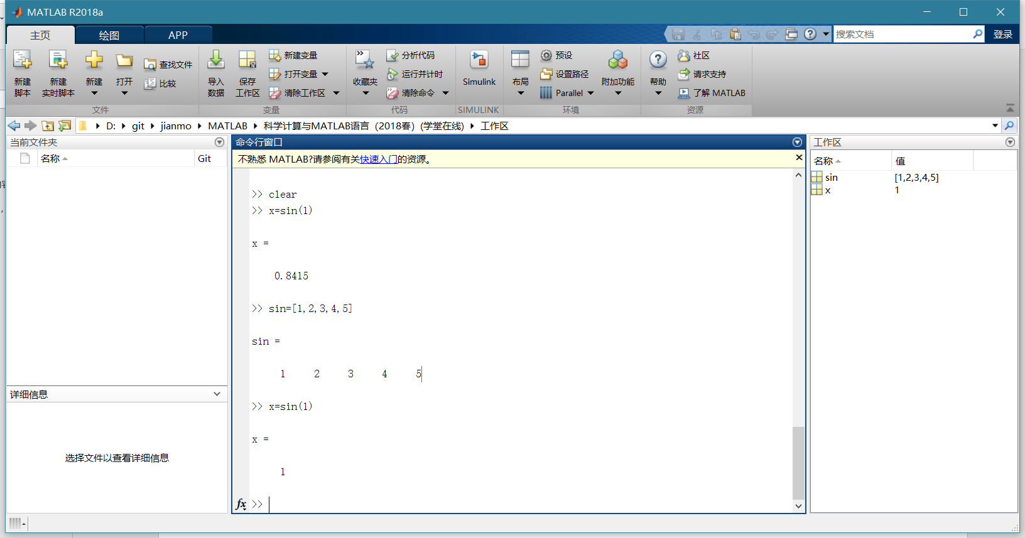

## 数值数据类型的分类

>> x=int8(129)

x =

int8

127

>> x=uint8(129)

x =

uint8

129

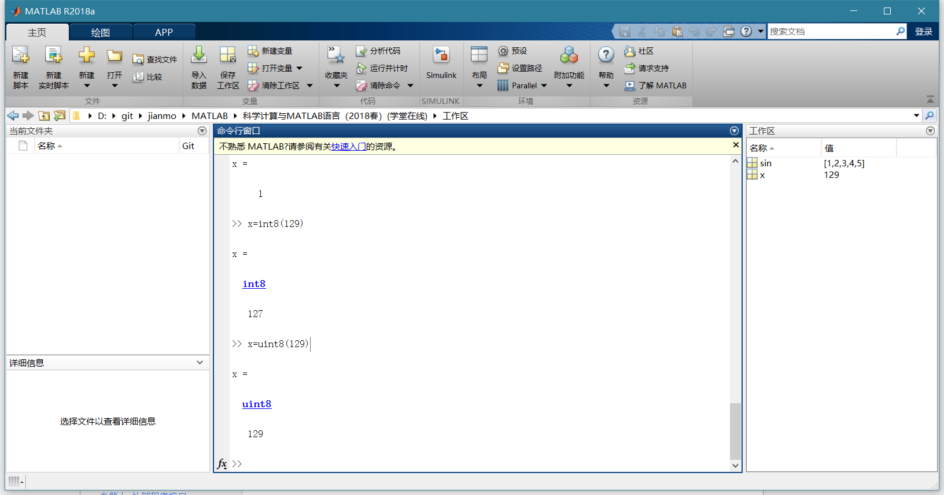

>> class(4)

ans =

'double'

>> class(single(4))

ans =

'single'

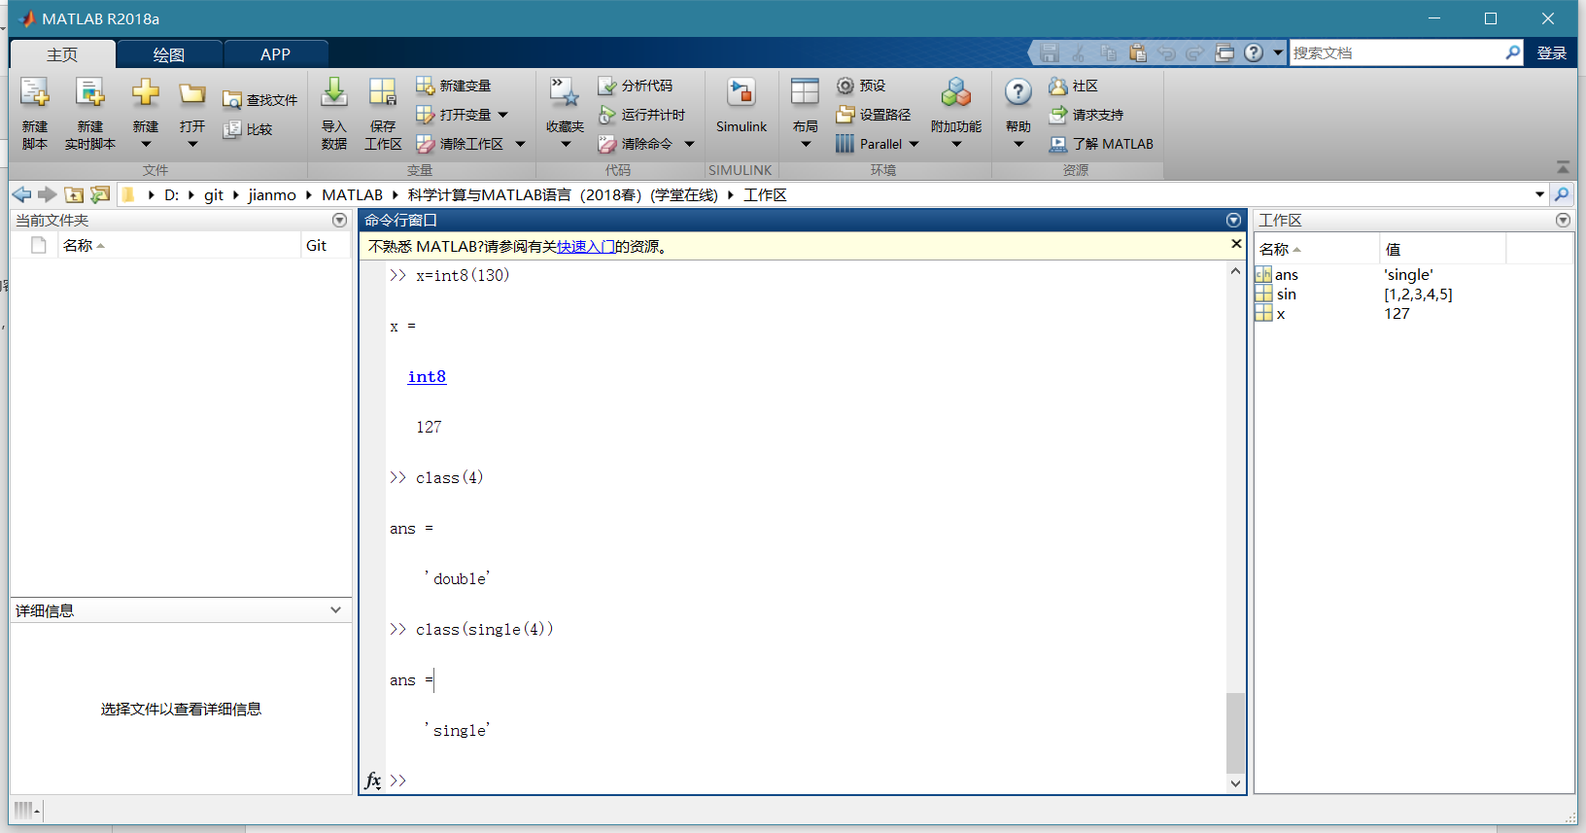

>> 6+5i

ans =

6.0000 + 5.0000i

>> 6+5j

ans =

6.0000 + 5.0000i

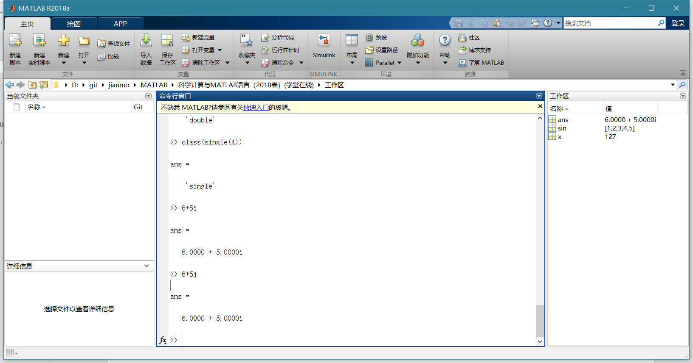

>> format long

>> 50/3

ans =

16.666666666666668

>> format

>> 50/3

ans =

16.6667

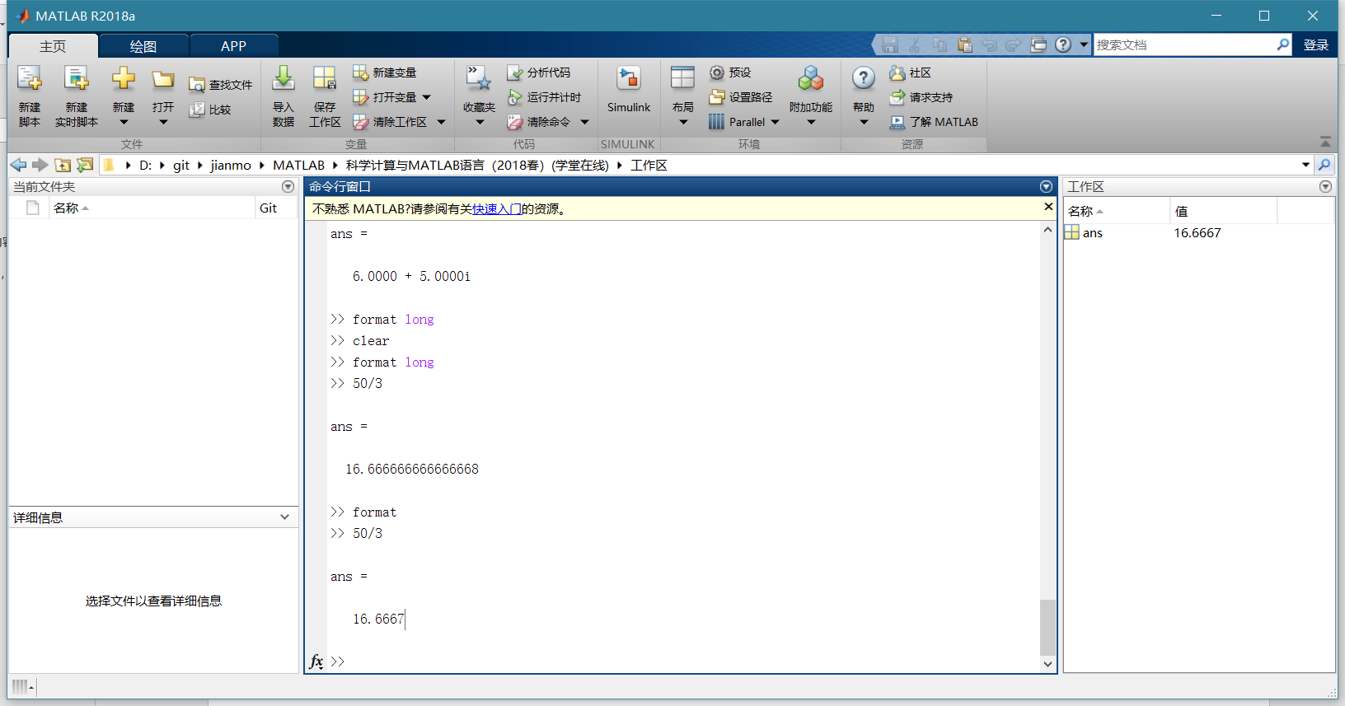

format命令只影响数据输出格式，而不影响数据的计算和存储

>> A=[4,2;3,6]

A =

4 2

3 6

>> B=exp(A)

B =

54.5982 7.3891

20.0855 403.4288

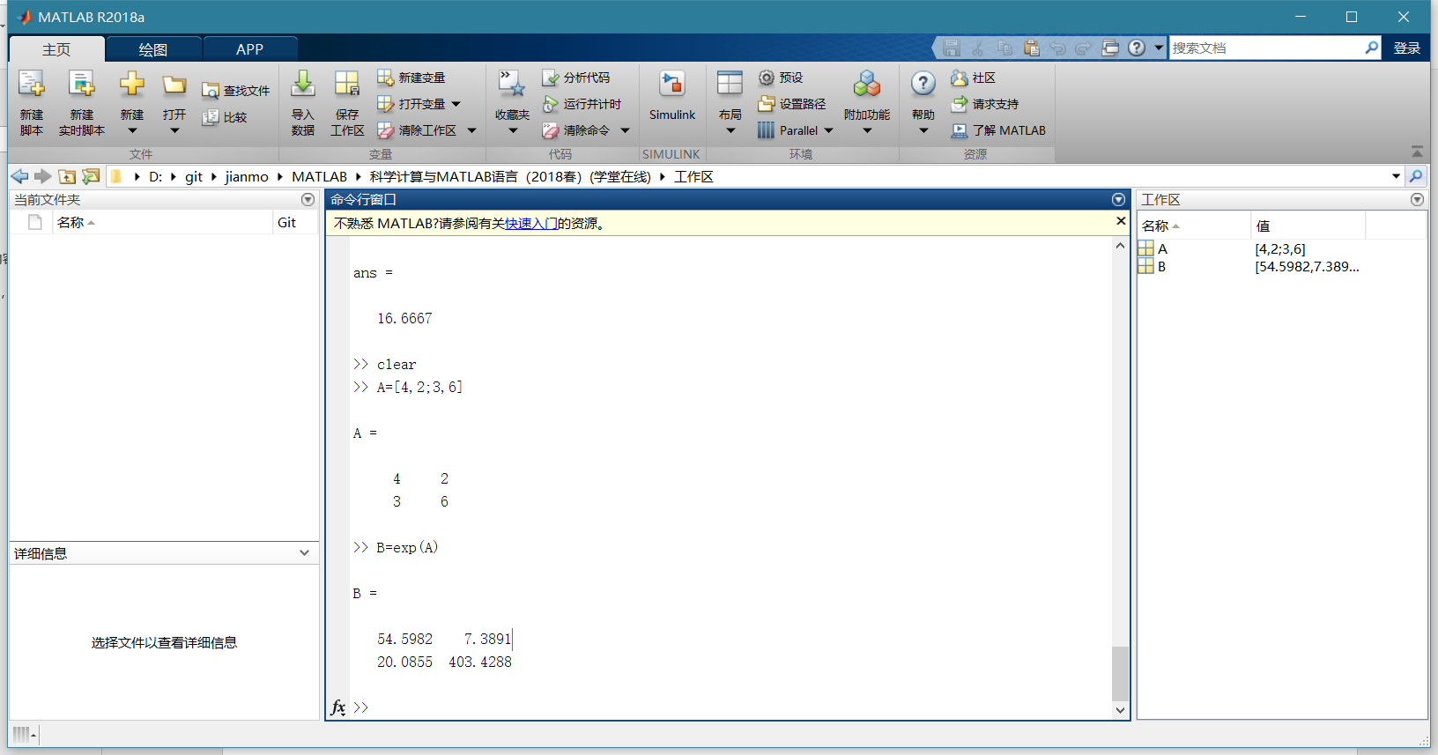

>> sin(pi/2)

ans =

1

>> sind(90)

ans =

1

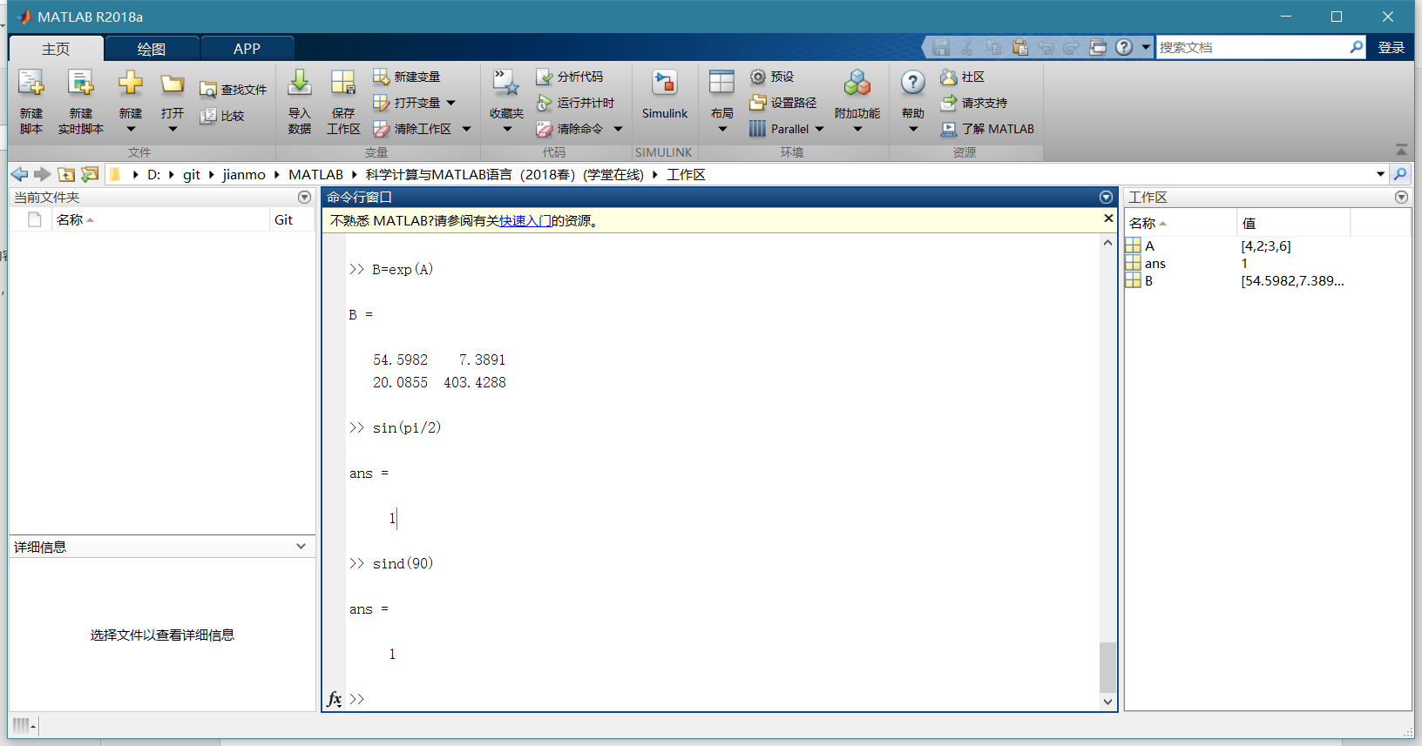

>> abs(-4)

ans =

4

>> abs(3+4i)

ans =

5

>> abs('a')

ans =

97

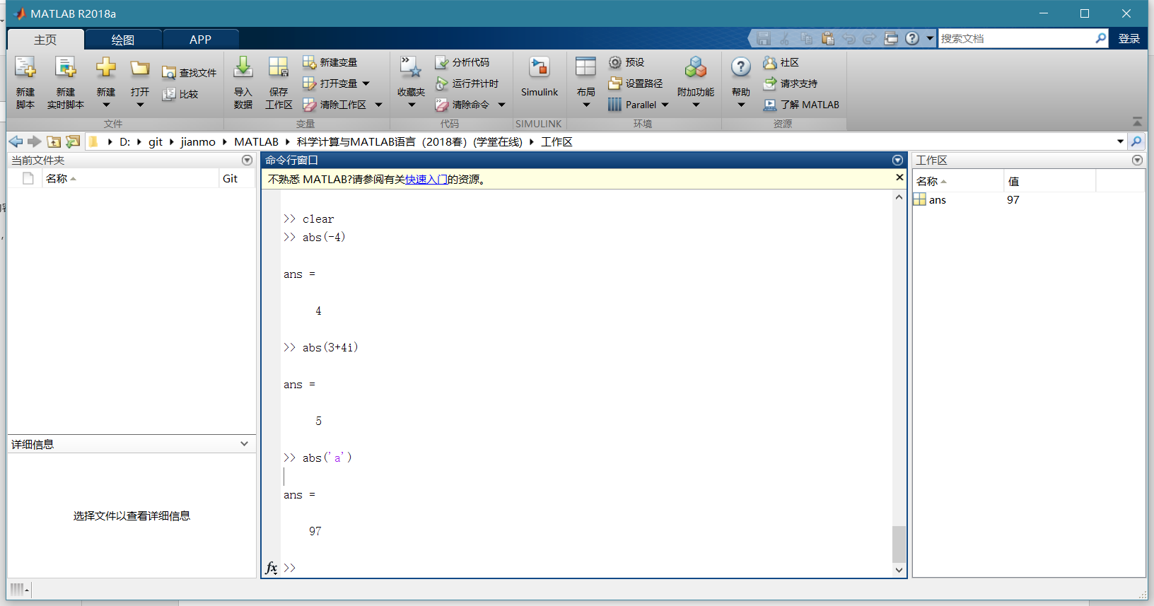

>> round(4.7)

ans =

5

>> fix(-3.2)

ans =

-3

>> floor(3.6)

ans =

3

>> ceil(-3.8)

ans =

-3

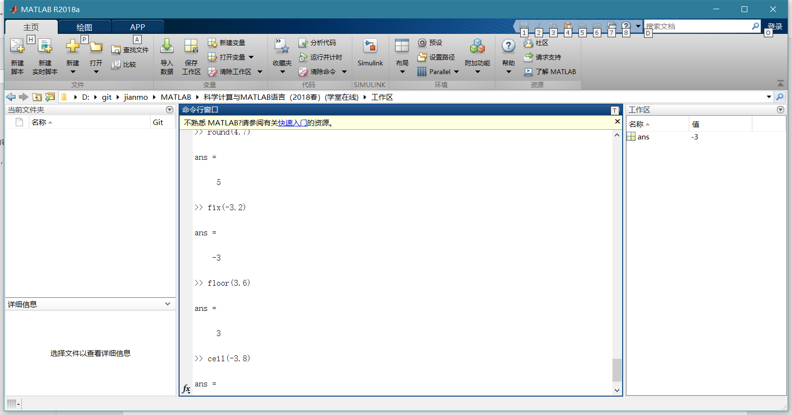

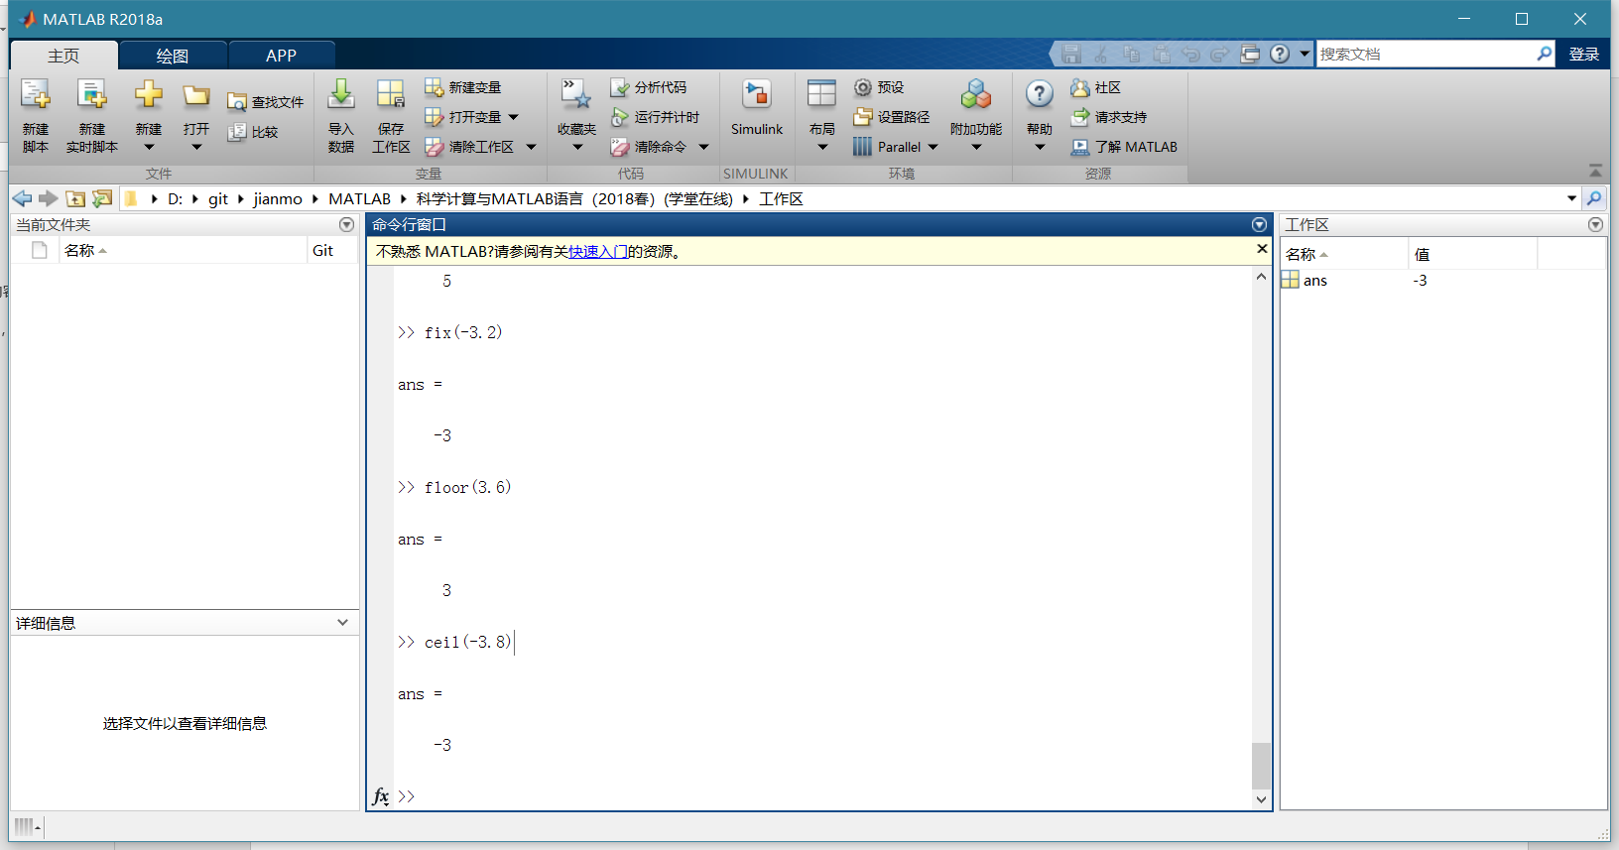

分别求一个三位正整数的个位数字、十位数字和百位数字。

>> m=345;

>> m1=rem(m,10)

m1 =

5

>> m2=rem(fix(m/10),10)

m2 =

4

>> m3=fix(m/100)

m3 =

3

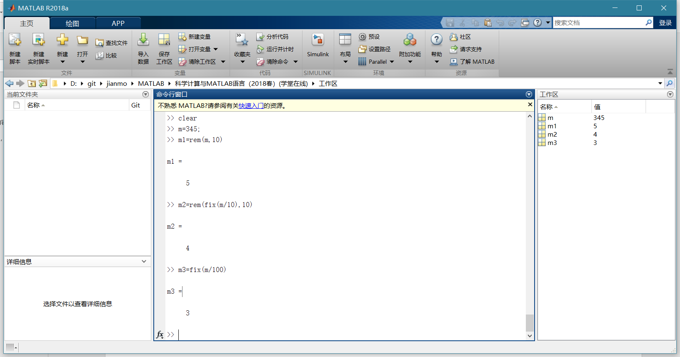

求[1,100]区间的所有素数

>> x=1:100;

>> k=isprime(x);

>> k1=find(k);

>> p=x(k1)

p =

1 至 15 列

2 3 5 7 11 13 17 19 23 29 31 37 41 43 47

16 至 25 列

53 59 61 67 71 73 79 83 89 97

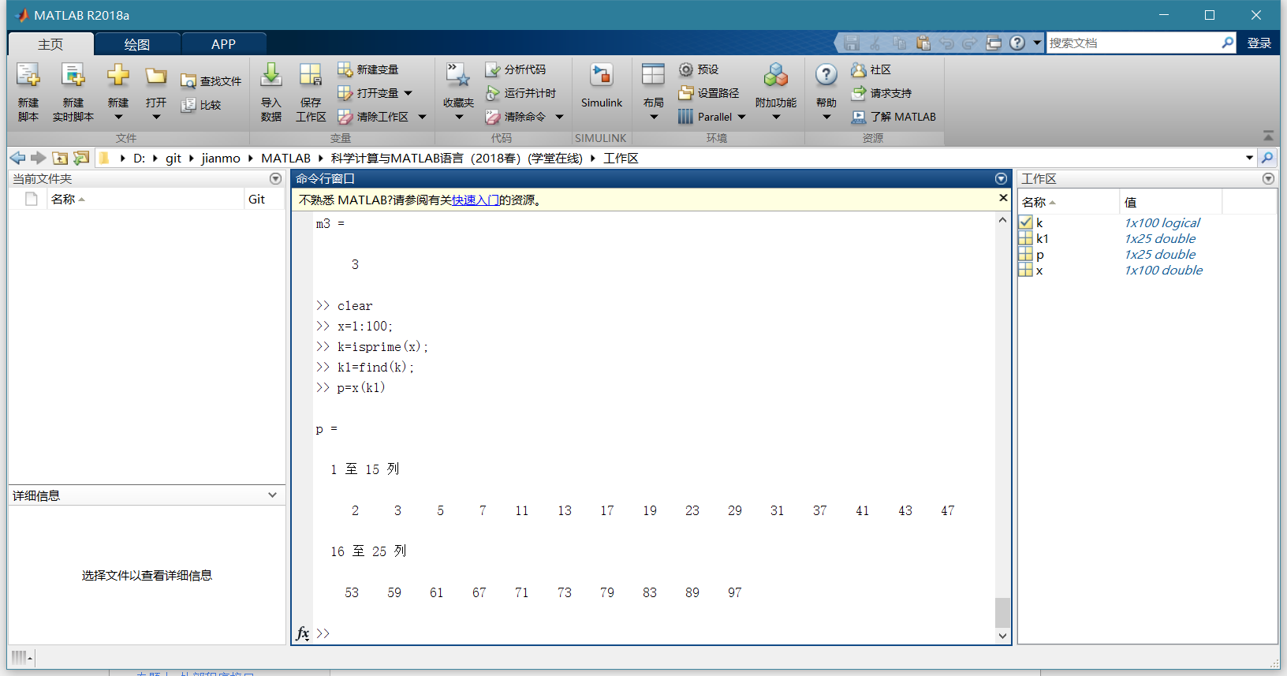

## 变量与赋值语句

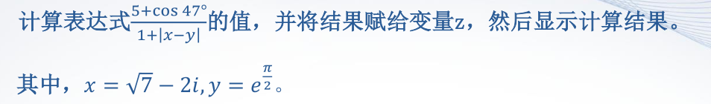

>> x=sqrt(7)-2i;

>> y=exp(pi/2);

>> z=(5+cosd(47))/(1+abs(x-y))

z =

1.4395

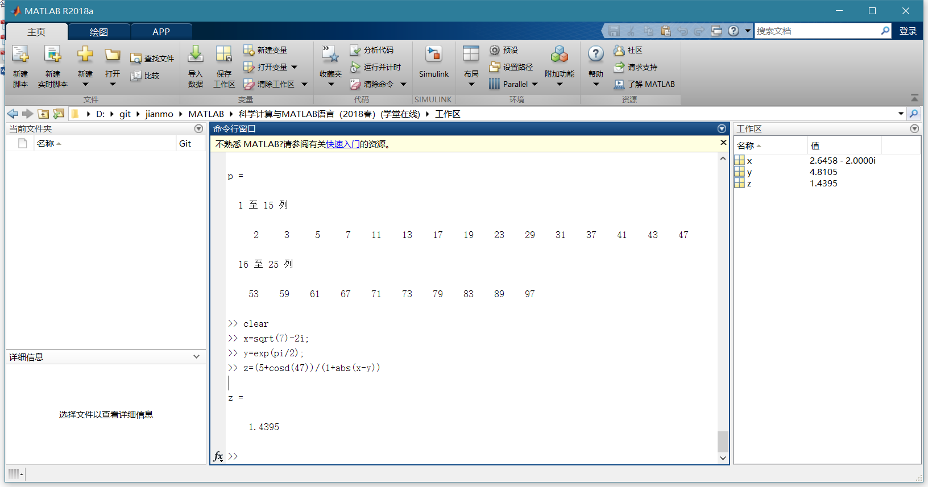

>> save mydata a x

>> load mydata

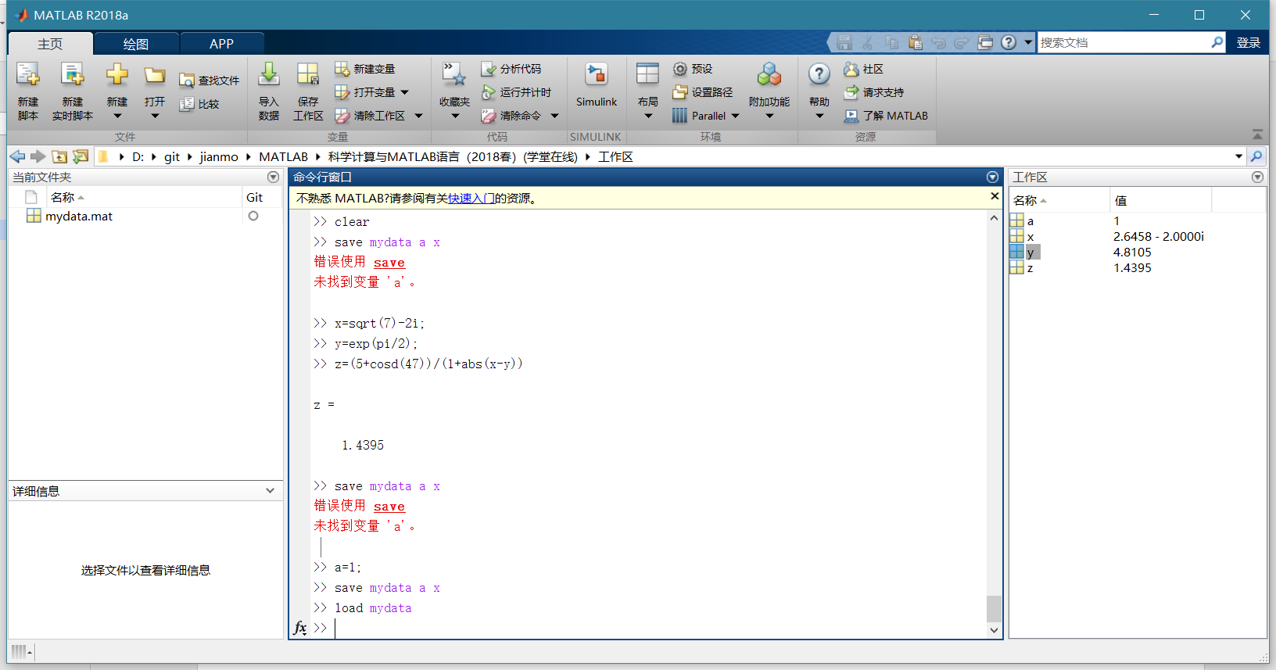

## 矩阵的建立

>> A=[1,2,3;4,5,6;7,8,9]

A =

1 2 3

4 5 6

7 8 9

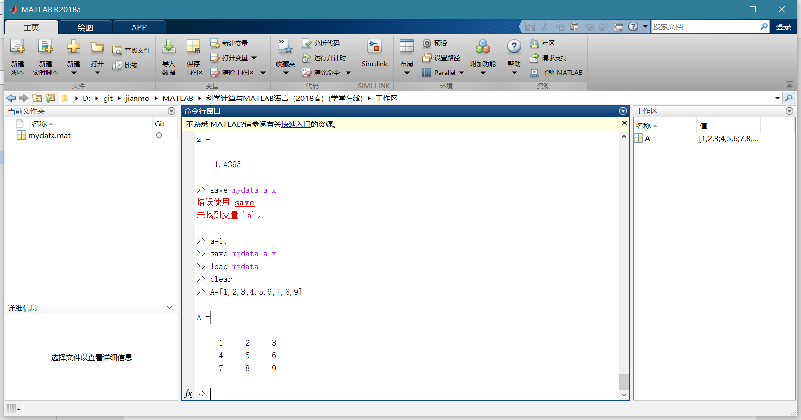

>> B=[-1,-2,-3;-4,-5,-6;-7,-8,-9];

>> C=[A,B;B,A]

C =

1 2 3 -1 -2 -3

4 5 6 -4 -5 -6

7 8 9 -7 -8 -9

-1 -2 -3 1 2 3

-4 -5 -6 4 5 6

-7 -8 -9 7 8 9

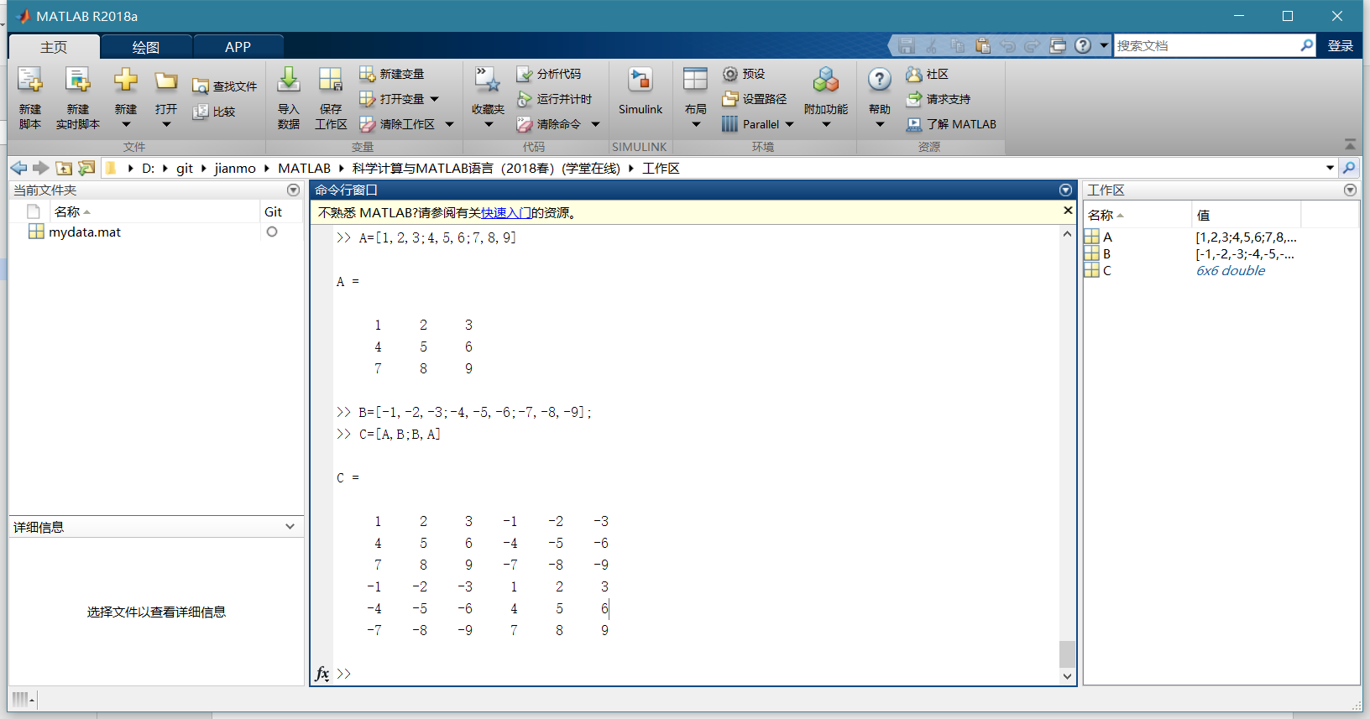

>> B=[1,2,3;4,5,6]

B =

1 2 3

4 5 6

>> C=[6,7,8;9,10,11];

>> A=B+i*C

A =

1.0000 + 6.0000i 2.0000 + 7.0000i 3.0000 + 8.0000i

4.0000 + 9.0000i 5.0000 +10.0000i 6.0000 +11.0000i

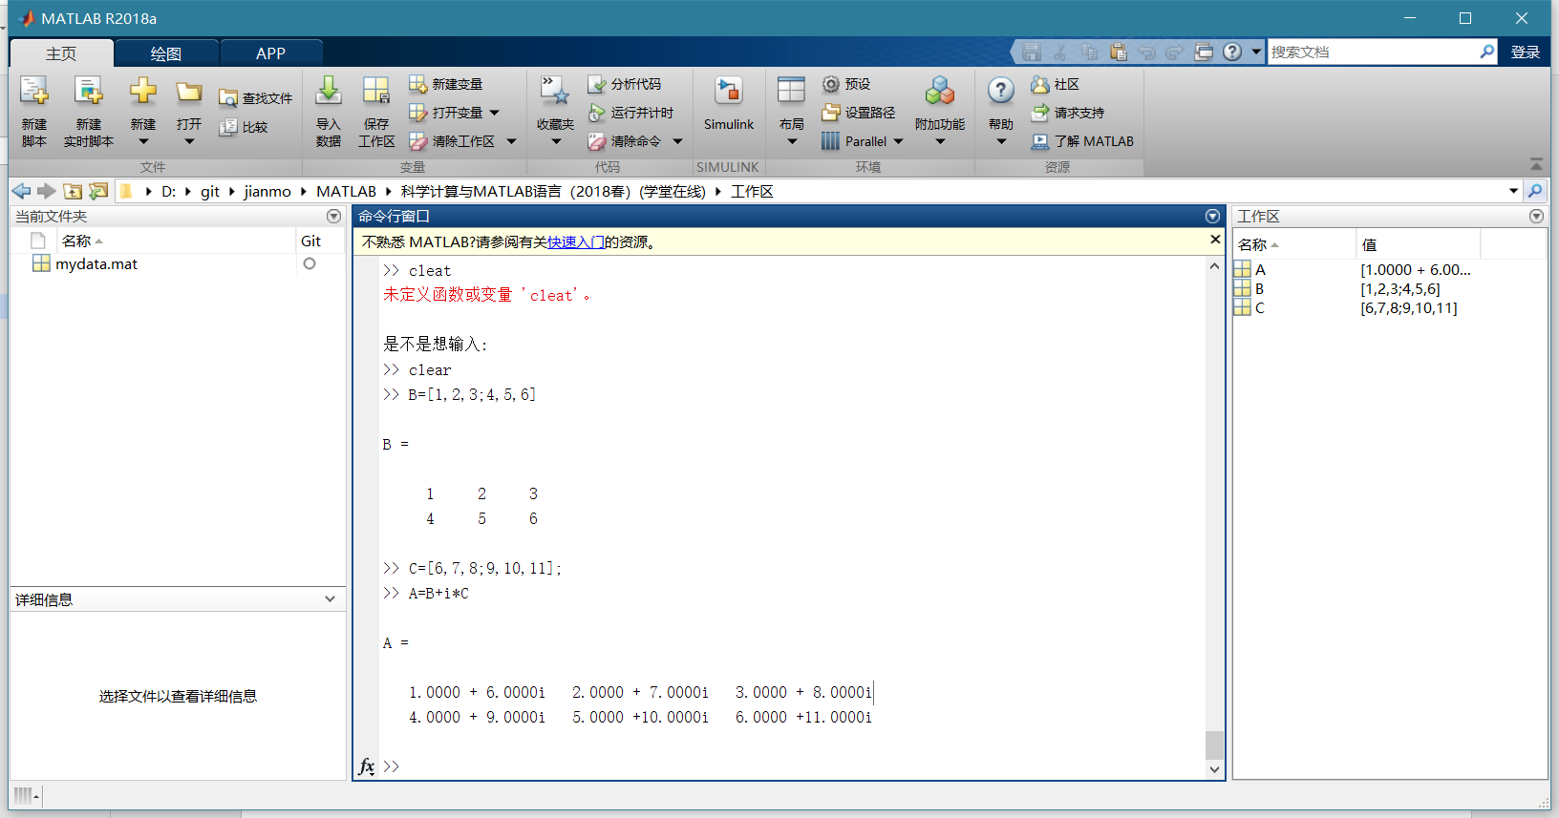

>> t=0:1:5

t =

0 1 2 3 4 5

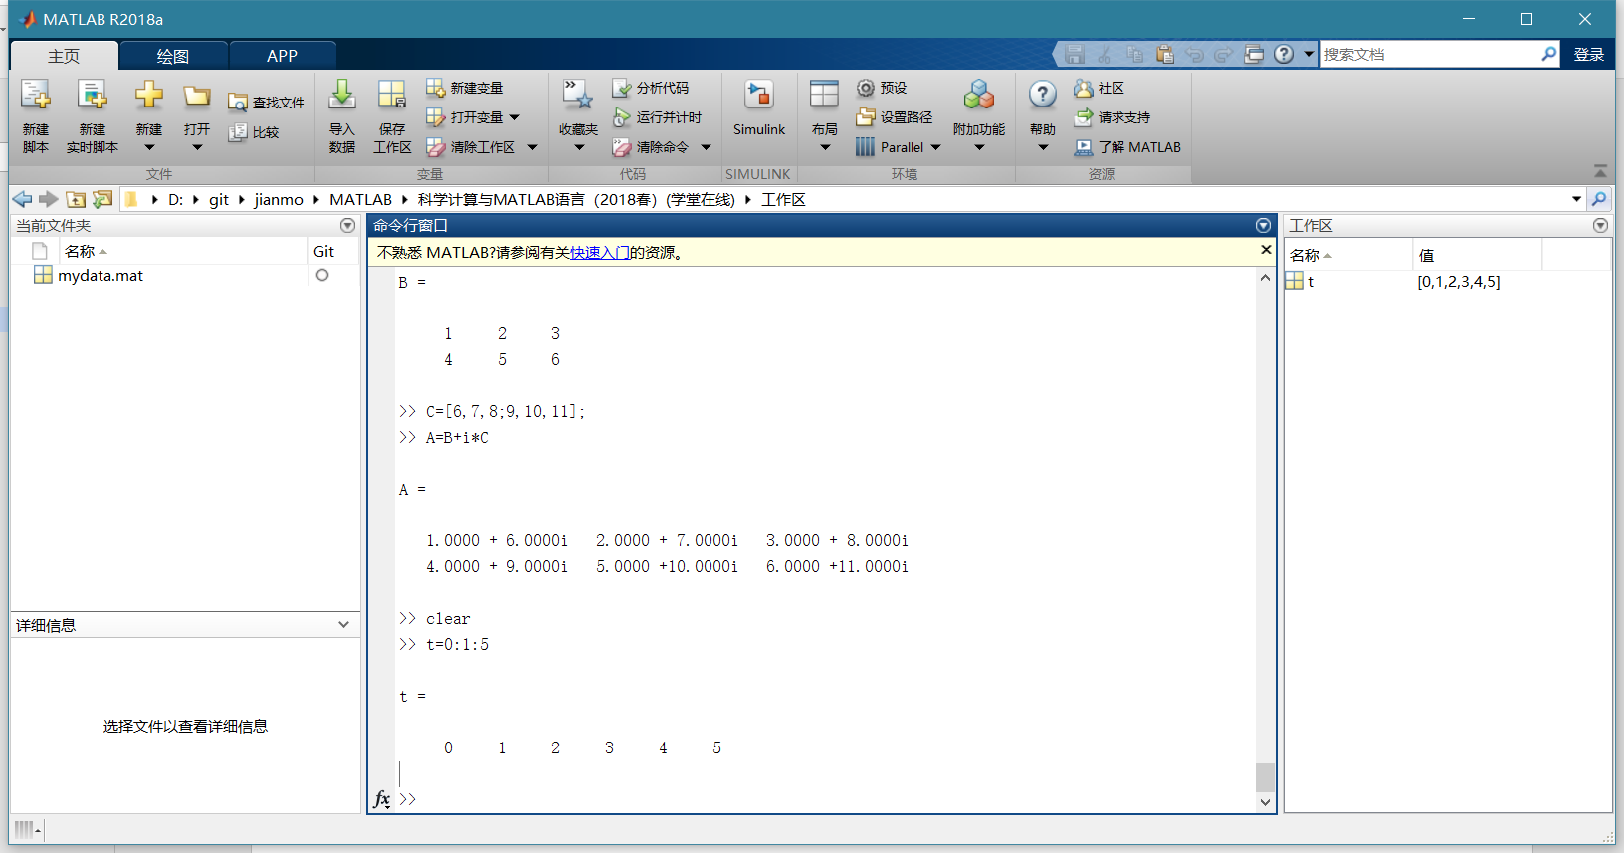

>> x=linspace(0,pi,6)

x =

0 0.6283 1.2566 1.8850 2.5133 3.1416

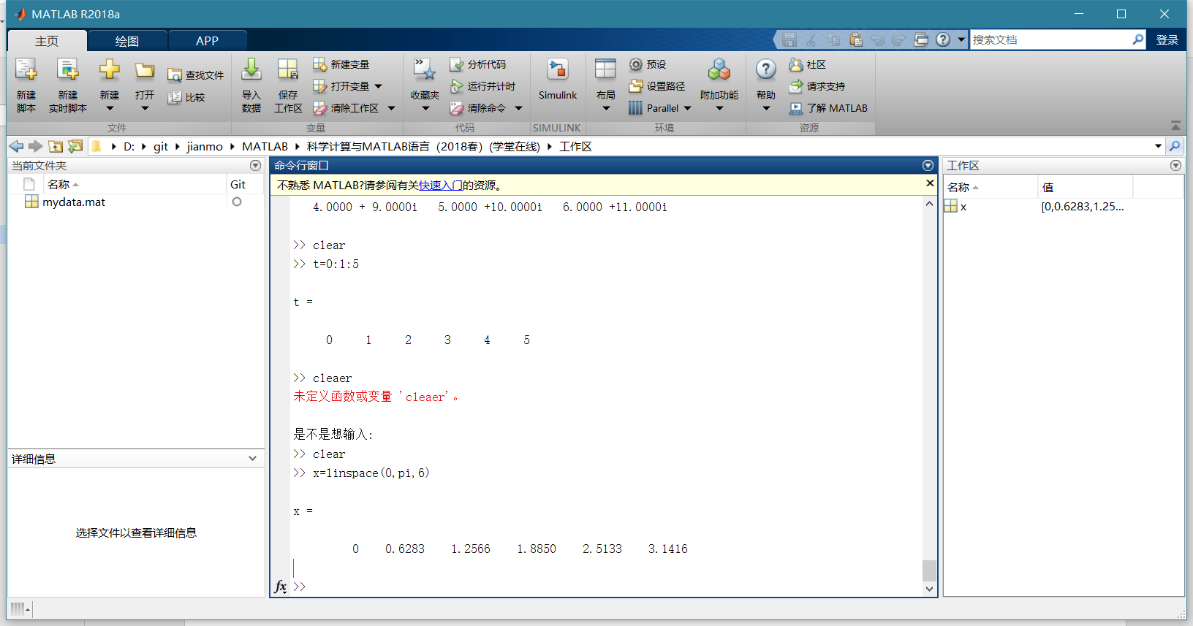

结构矩阵

>> a(1).x1=10;a(1).x2='liu';a(1).x3=[11,21;34,78];

>> a(2).x1=12;a(2).x2='wang';a(2).x3=[34,191;27,578];

>> a(3).x1=14;a(3).x2='cai';a(3).x3=[13,890;67,231];

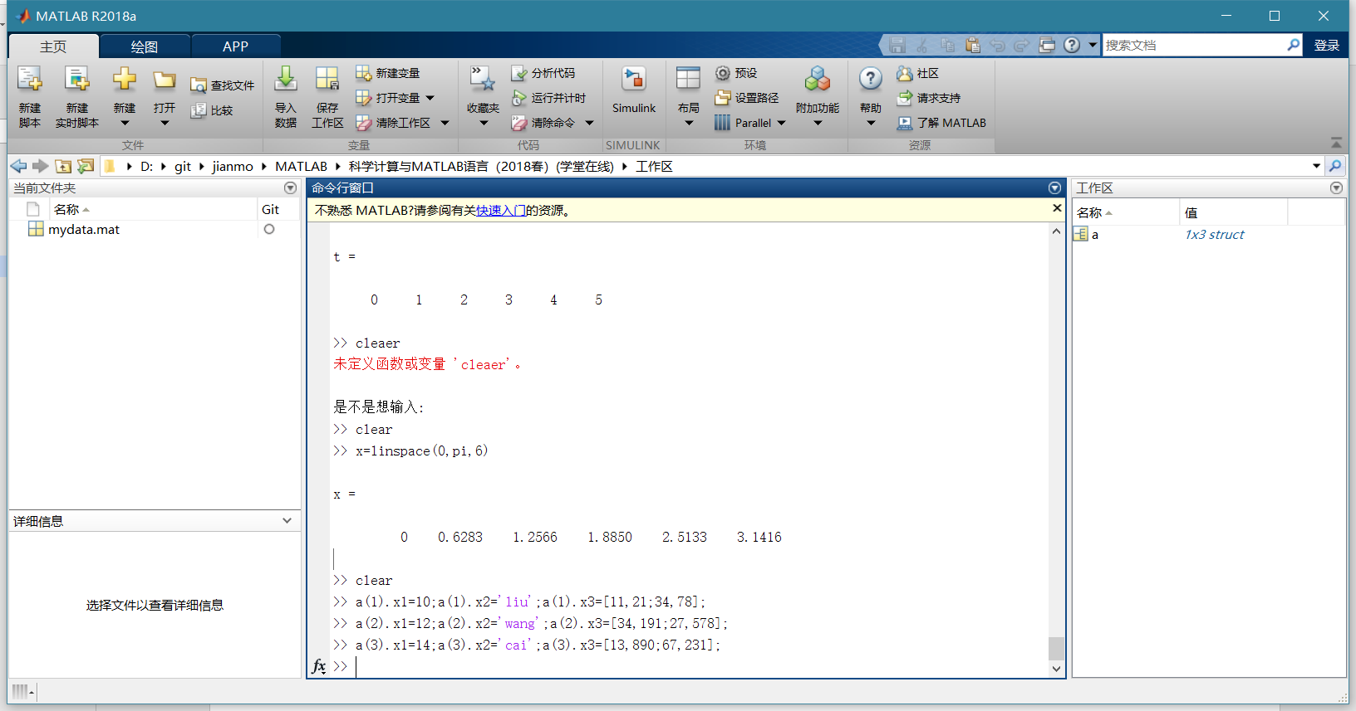

>> a(1).x1=10;a(1).x2='liu';a(1).x3=[11,21;34,78]

a =

包含以下字段的 struct:

x1: 10

x2: 'liu'

x3: [2×2 double]

>> a(2).x1=12;a(2).x2='wang';a(2).x3=[34,191;27,578]

a =

包含以下字段的 1×2 struct 数组:

x1

x2

x3

>> a(3).x1=14;a(3).x2='cai';a(3).x3=[13,890;67,231]

a =

包含以下字段的 1×3 struct 数组:

x1

x2

x3

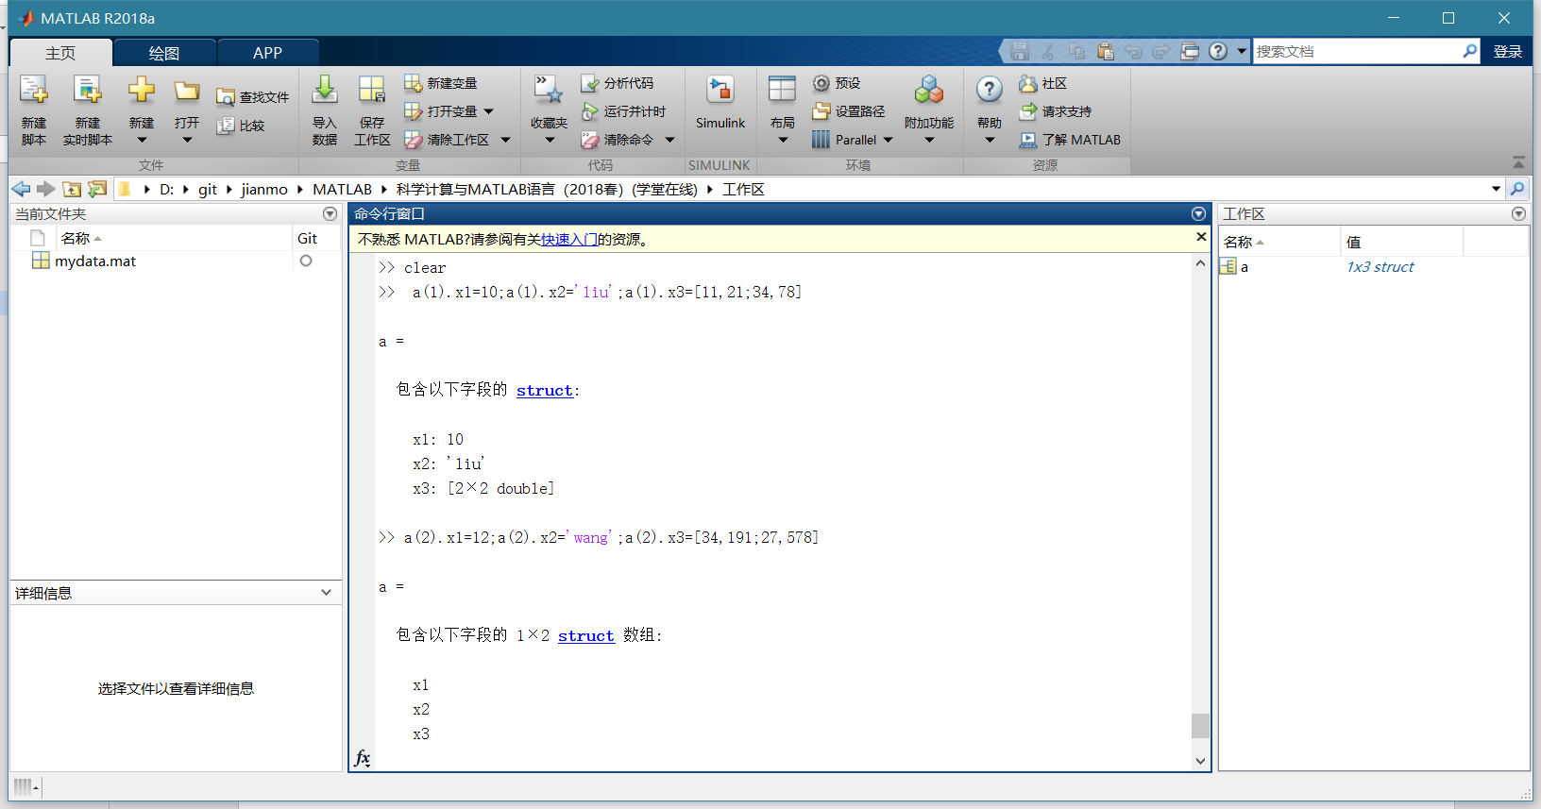

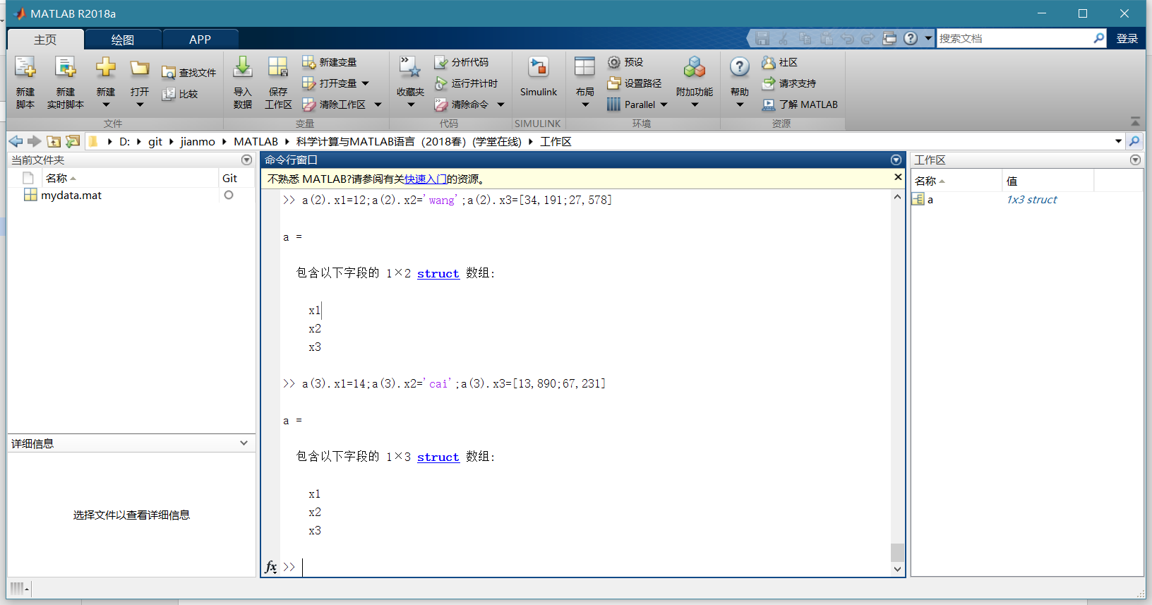

单元矩阵

>> b={10,'liu',[11,21;34,78];12,'wang',[34,191;27,578];14,'cai',[13,890;67,231]}

b =

3×3 cell 数组

{[10]} {'liu' } {2×2 double}

{[12]} {'wang'} {2×2 double}

{[14]} {'cai' } {2×2 double}

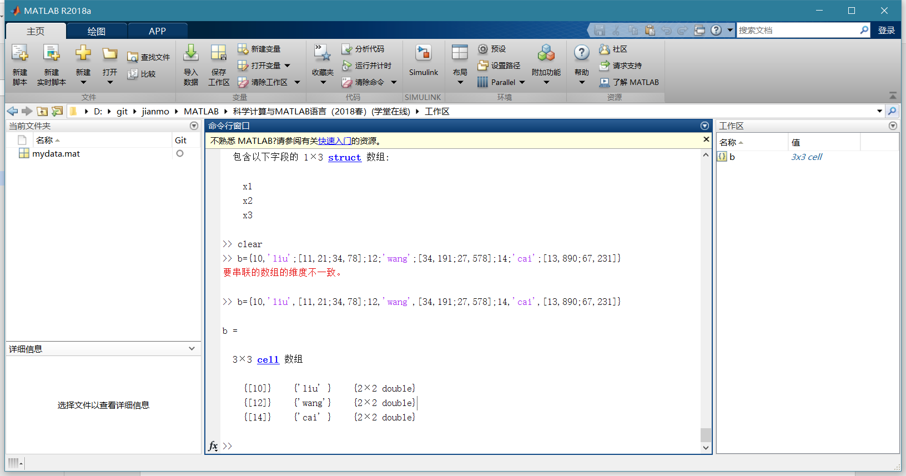

## 矩阵元素的引用

>> A=[1,2,3;4,5,6];

>> A(4,5)=10

A =

1 2 3 0 0

4 5 6 0 0

0 0 0 0 0

0 0 0 0 10

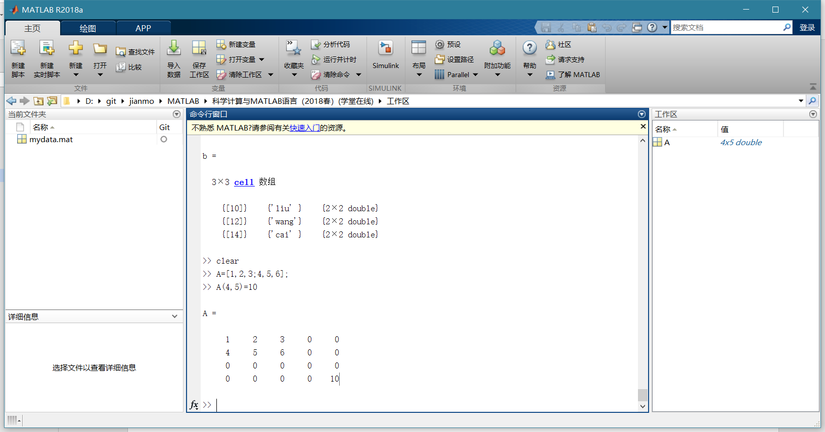

>> A=[1,2,3;4,5,6]

A =

1 2 3

4 5 6

>> A(3)

ans =

2

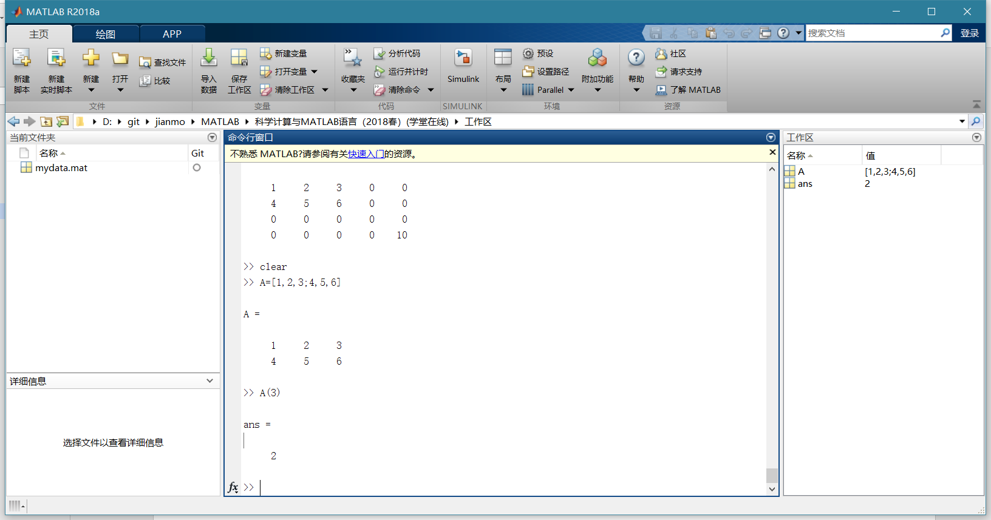

>> A=[1:3;4:6]

A =

1 2 3

4 5 6

>> D=sub2ind(size(A),[1,2;2,2],[1,1;3,2])

D =

1 2

6 4

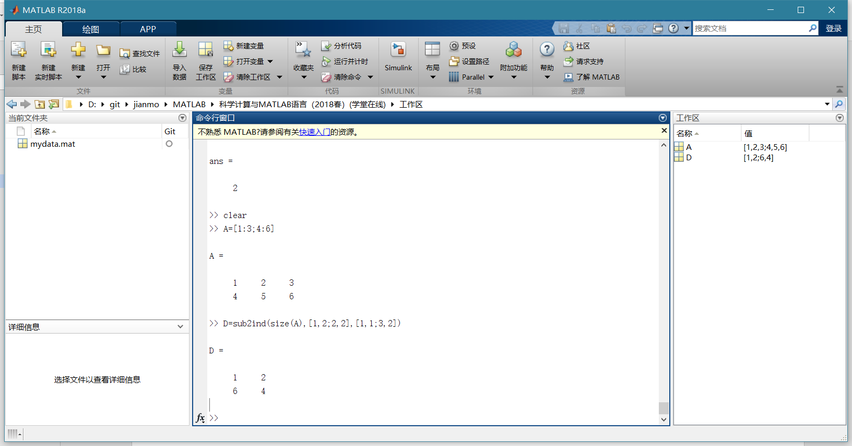

>> [I,J]=ind2sub([3,3],[1,3,5])

I =

1 3 2

J =

1 1 2

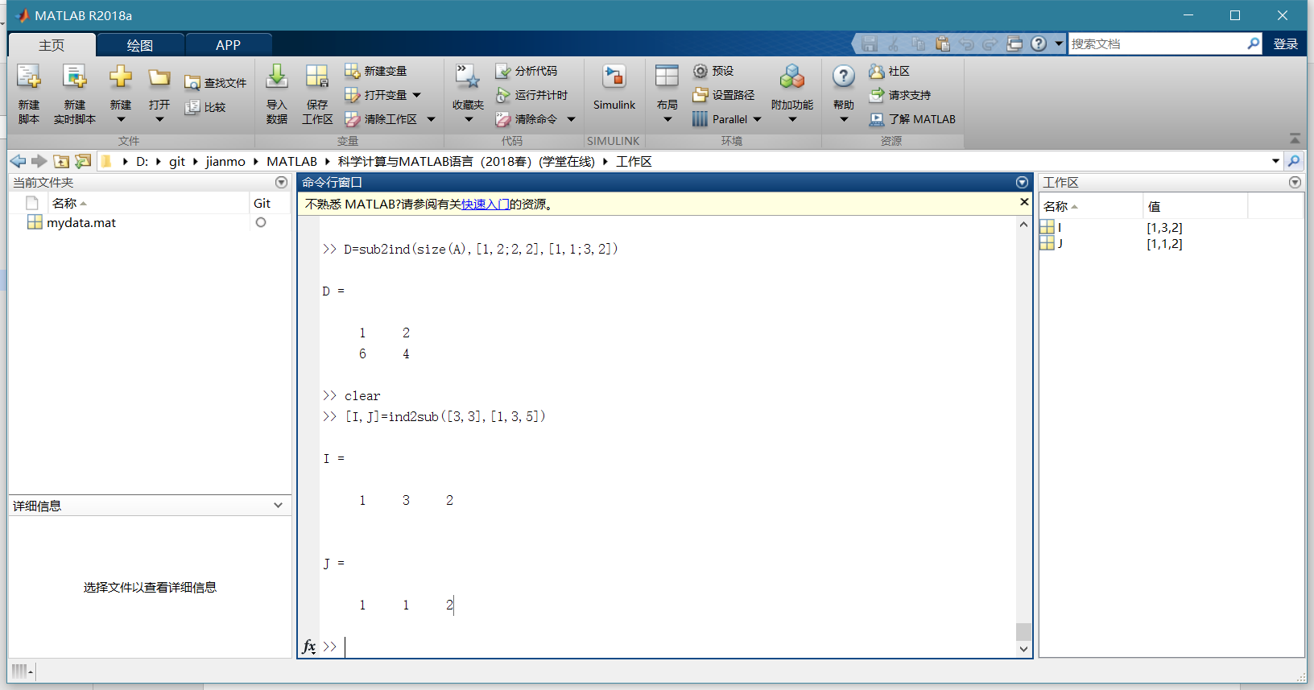

>> A=[1,2,3,4,5;6,7,8,9,10;11,12,13,14,15]

A =

1 2 3 4 5

6 7 8 9 10

11 12 13 14 15

>> A(1:2,:)

ans =

1 2 3 4 5

6 7 8 9 10

>> A(2:3,1:2:5)

ans =

6 8 10

11 13 15

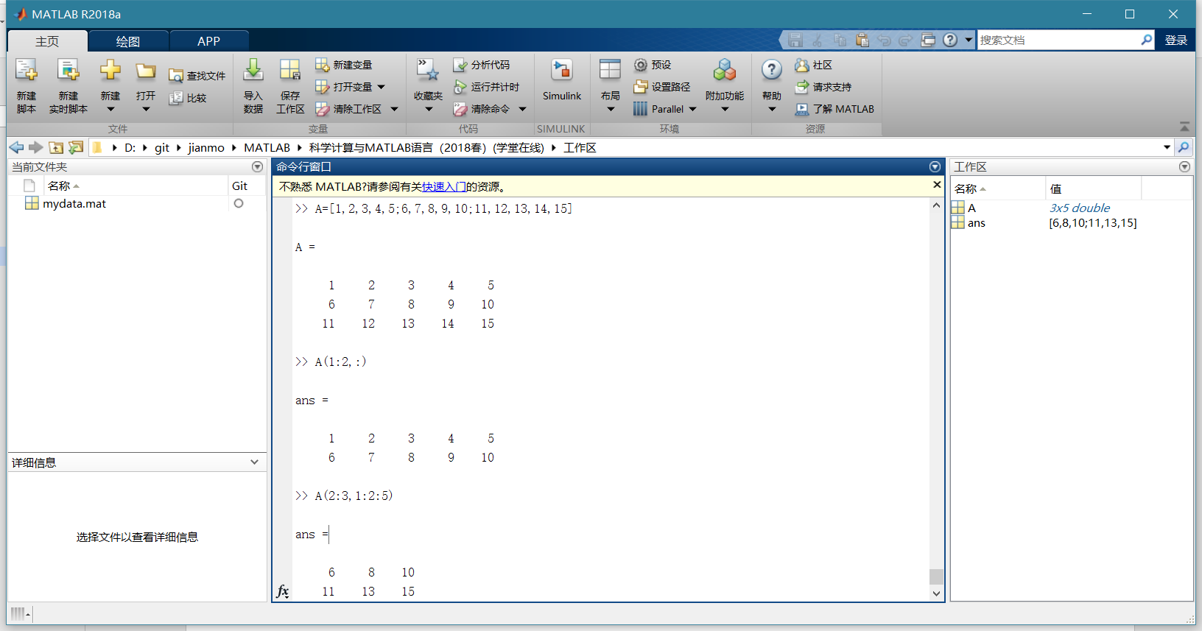

>> A=[1,2,3,4,5;6,7,8,9,10;11,12,13,14,15;16,17,18,19,20];

>> A(end,:)

ans =

16 17 18 19 20

>> A([1,4],3:end)

ans =

3 4 5

18 19 20

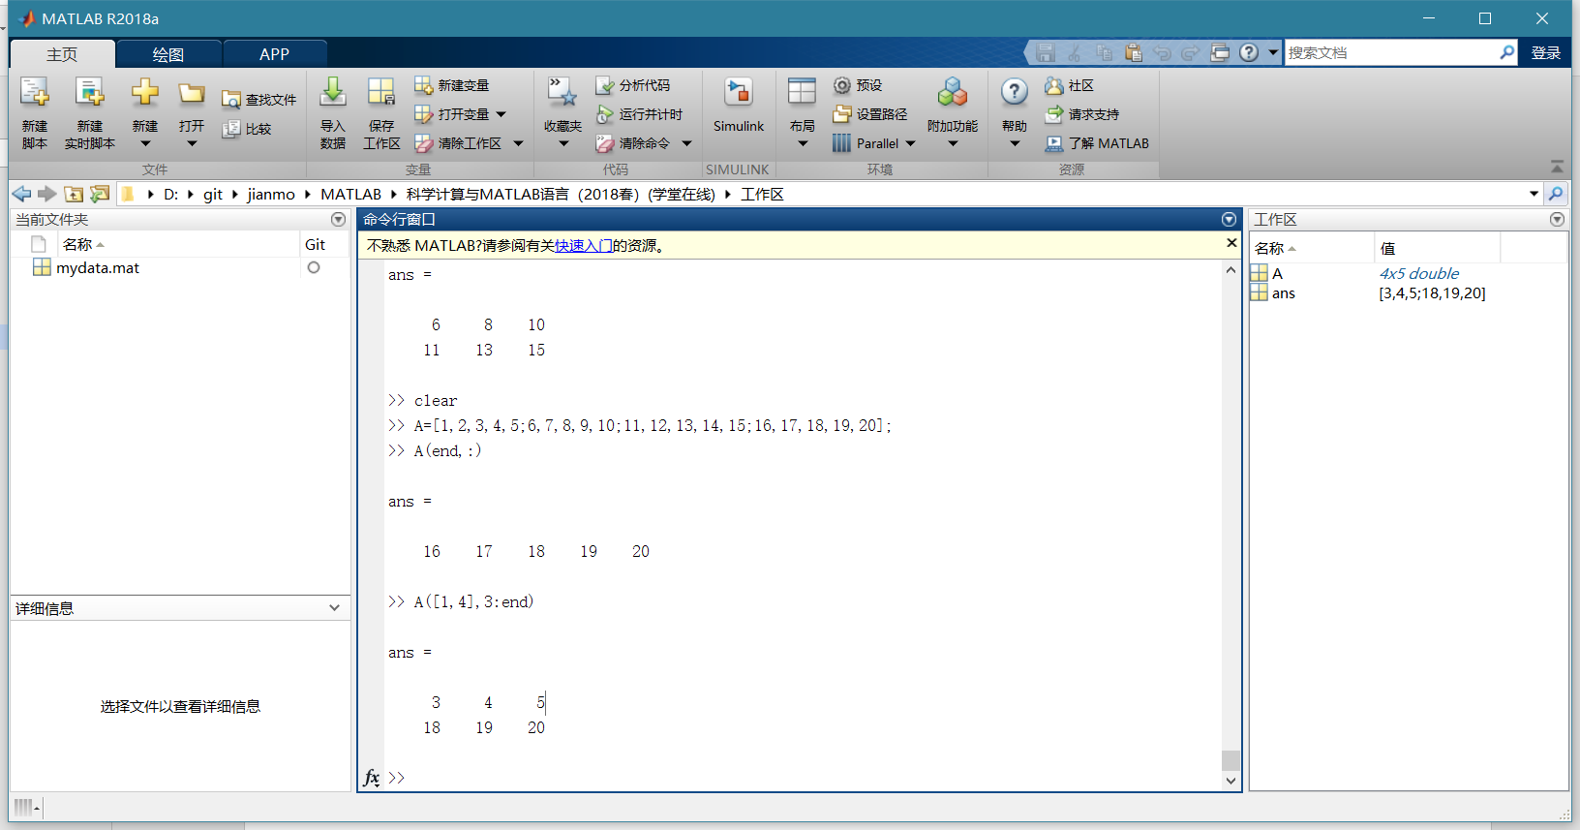

>> A=[1,2,3,0,0;7,0,9,2,6;1,4,-1,1,8]

A =

1 2 3 0 0

7 0 9 2 6

1 4 -1 1 8

>> A(:,[2,4])=[]

A =

1 3 0

7 9 6

1 -1 8

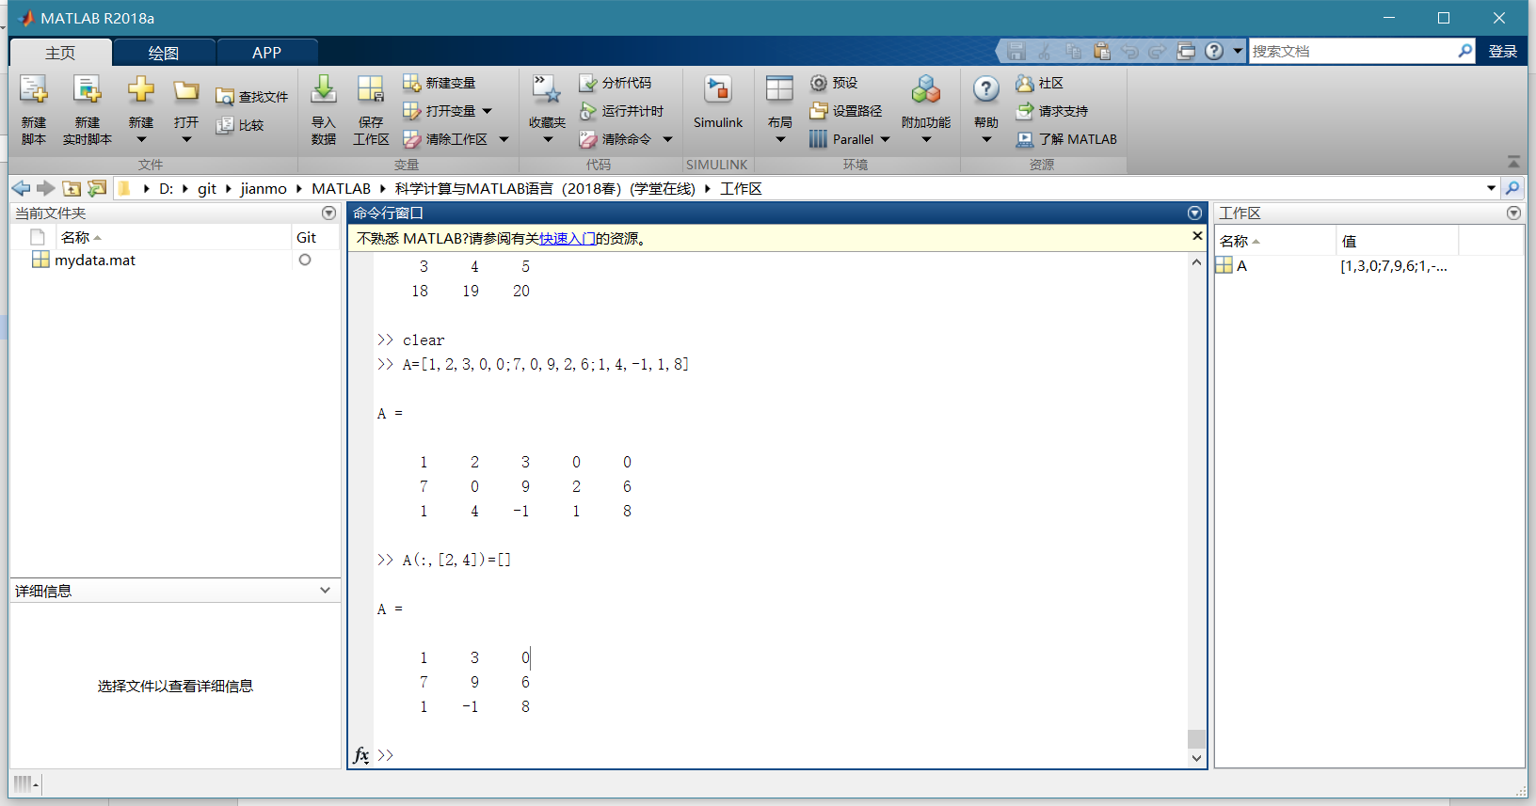

>> x=[23,45,65,34,65,34,98,45,78,65,43,76]

x =

23 45 65 34 65 34 98 45 78 65 43 76

>> y=reshape(x,3,4)

y =

23 34 98 65

45 65 45 43

65 34 78 76

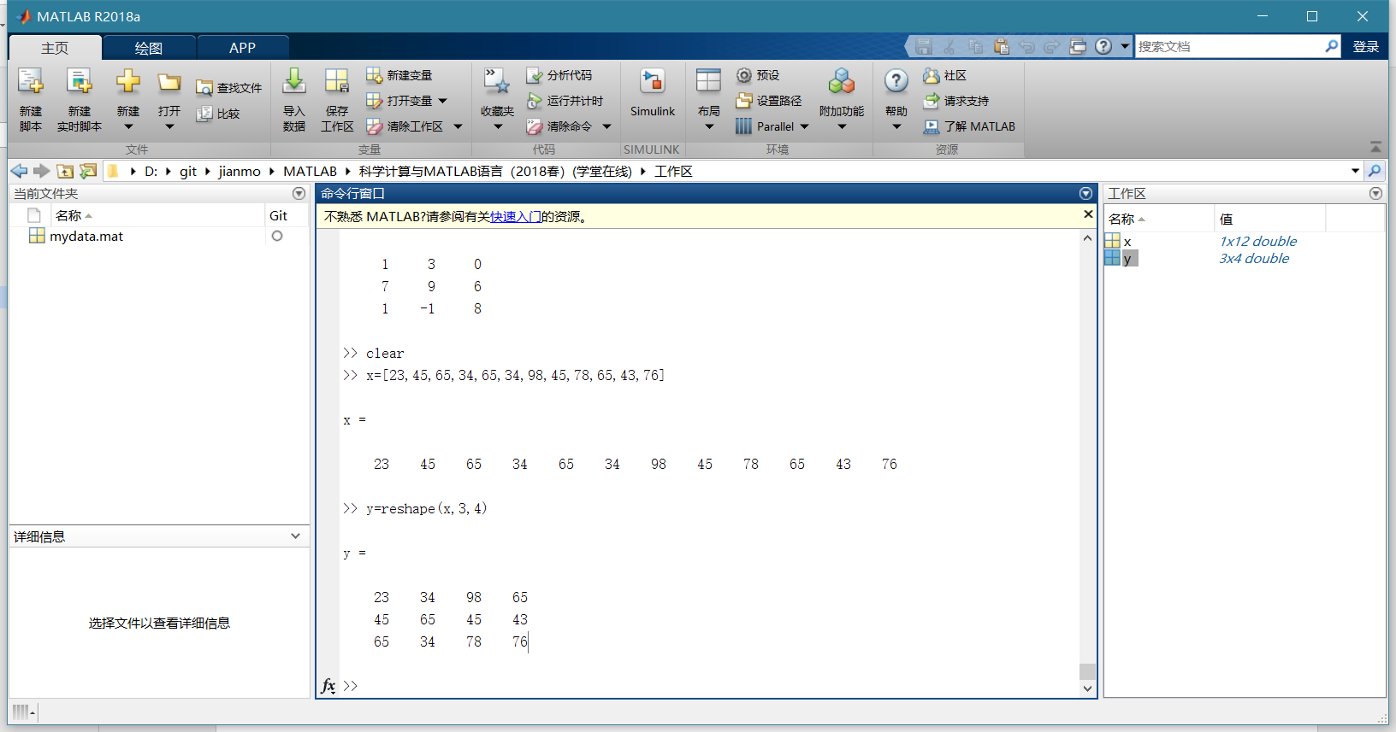

>> A=[-45,65,71;27,35,91]

A =

-45 65 71

27 35 91

>> B=A(:)

B =

-45

27

65

35

71

91

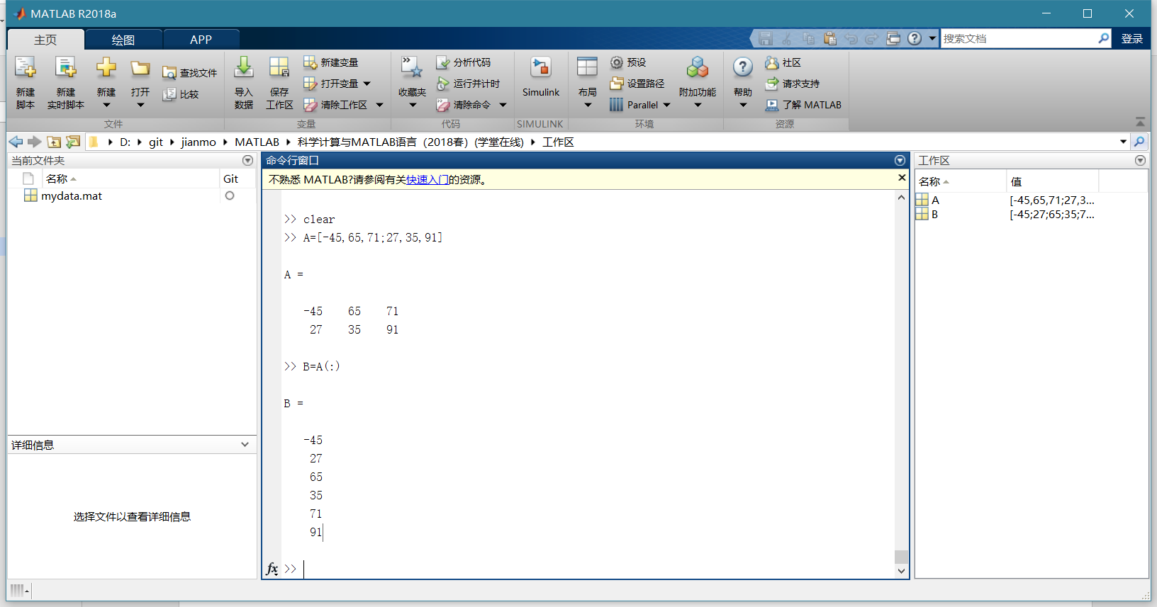

## MATLAB基本运算

>> A=[1,2,3;4,2,6;7,4,9];

>> B=[4,3,2;7,5,1;12,7,92];

>> C1=B/A

C1 =

-0.1667 -3.3333 2.5000

-0.8333 -7.6667 5.5000

12.8333 63.6667 -36.5000

>> C2=A\B

C2 =

0.5000 -0.5000 44.5000

1.0000 0.0000 46.0000

0.5000 1.1667 -44.8333

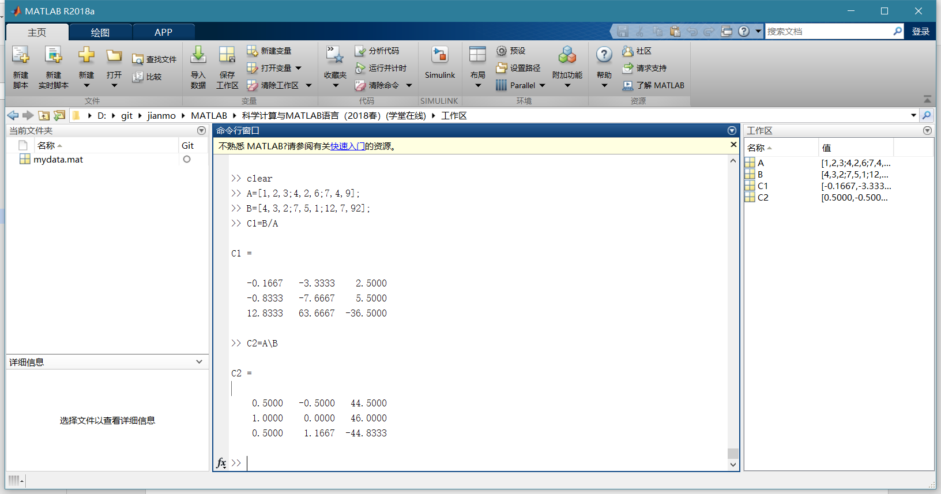

>> 3/4

ans =

0.7500

>> 4\3

ans =

0.7500

>> a=[10.5,25]

a =

10.5000 25.0000

>> a/5

ans =

2.1000 5.0000

>> 5\a

ans =

2.1000 5.0000

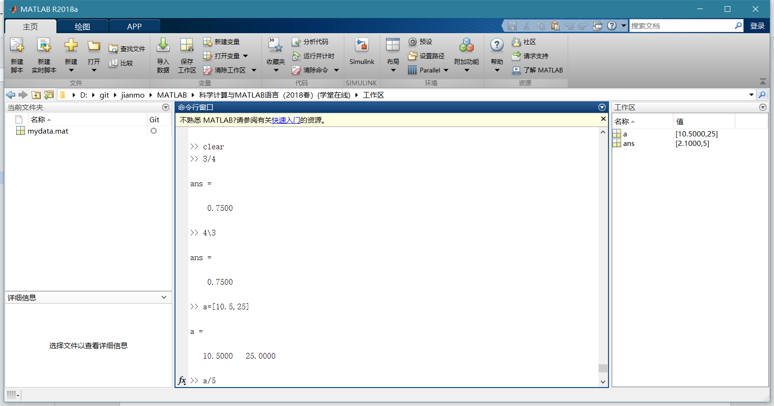

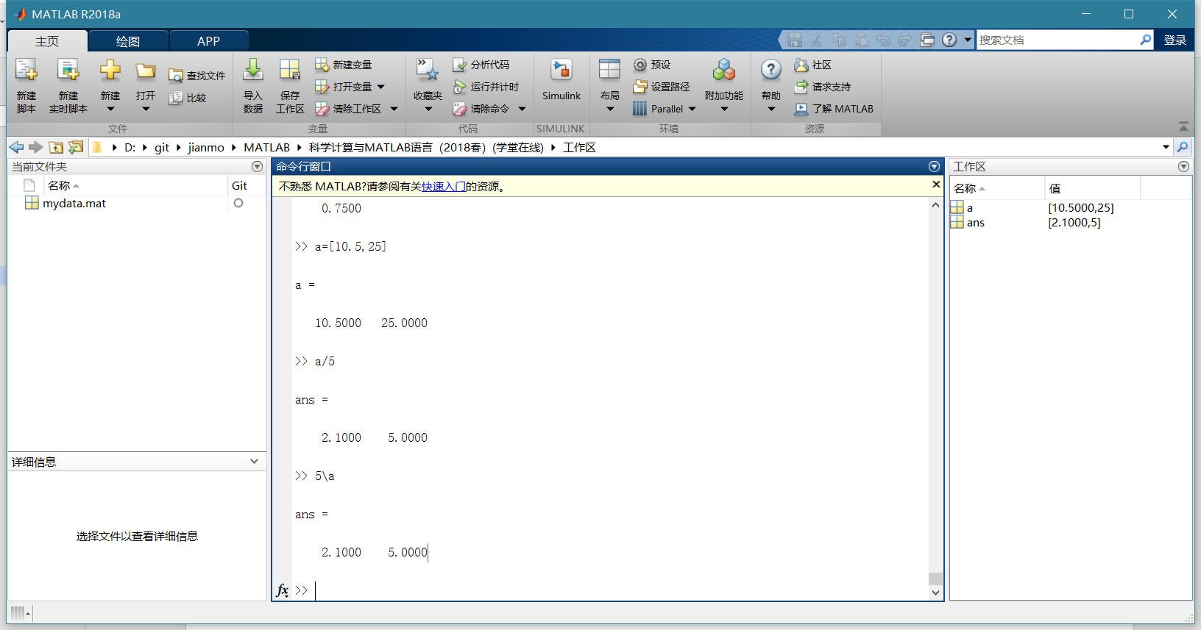

>> A=[1,2,3;4,5,6;7,8,0]

A =

1 2 3

4 5 6

7 8 0

>> A^2

ans =

30 36 15

66 81 42

39 54 69

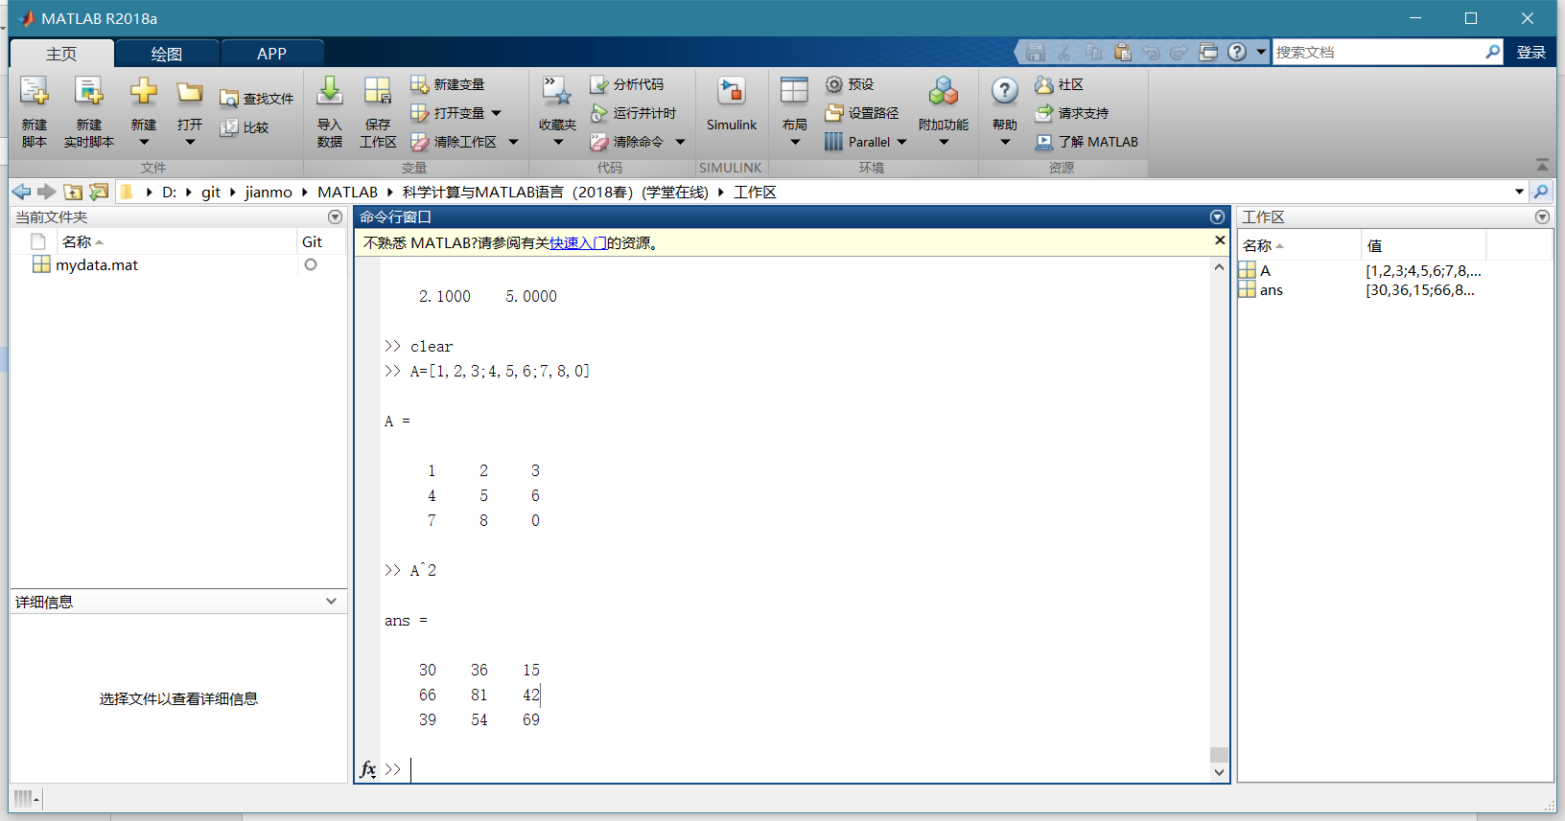

>> A=[1,2,3;4,5,6;7,8,9];

>> B=[-1,0,1;1,-1,0;0,1,1];

>> C=A.*B

C =

-1 0 3

4 -5 0

0 8 9

>> D=A*B

D =

1 1 4

1 1 10

1 1 16

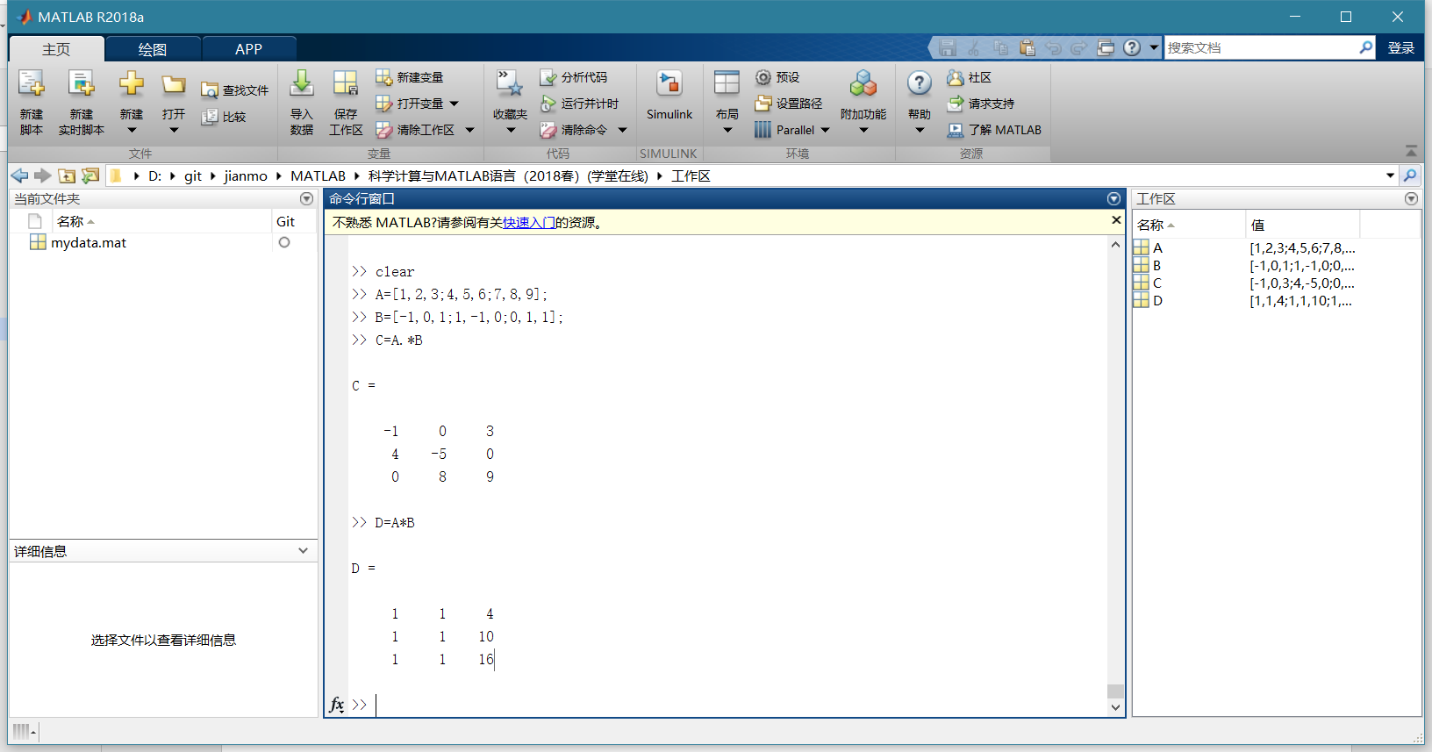

>> x=0.1:0.3:1;

>> y=sin(x).*cos(x);

>> y=sin(x).*cos(x)

y =

0.0993 0.3587 0.4927 0.4546

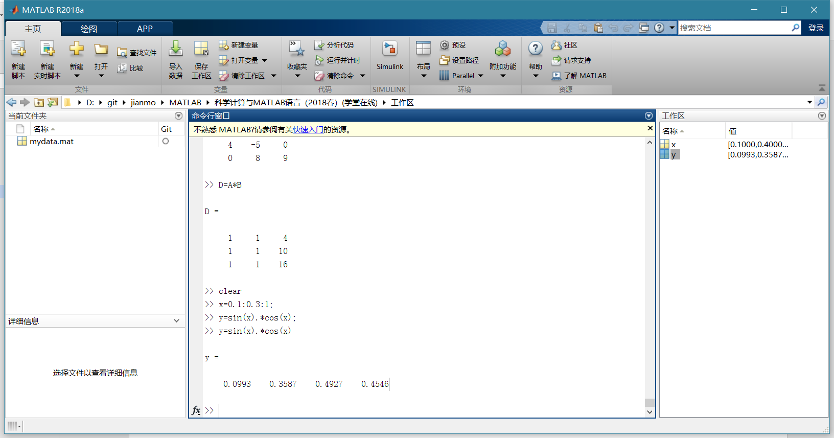

>> 3>4

ans =

logical

0

>> x=5

x =

5

>> x==5

ans =

logical

1

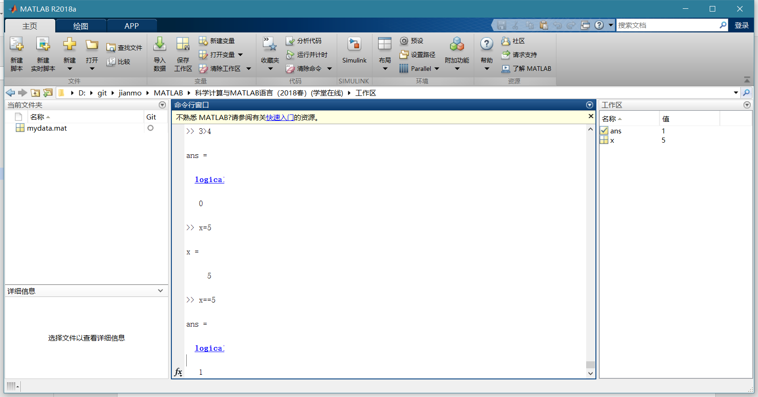

>> A=[24,35,13;22,63,23;39,47,80]

A =

24 35 13

22 63 23

39 47 80

>> P=rem(A,2)==0

P =

3×3 logical 数组

1 0 0

1 0 0

0 0 1

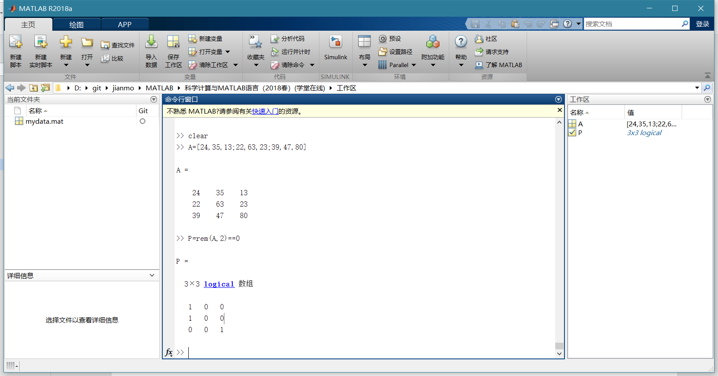

>> 3<4&6>5

ans =

logical

1

>> ~(9==1)

ans =

logical

1

>> ~9==1

ans =

logical

0

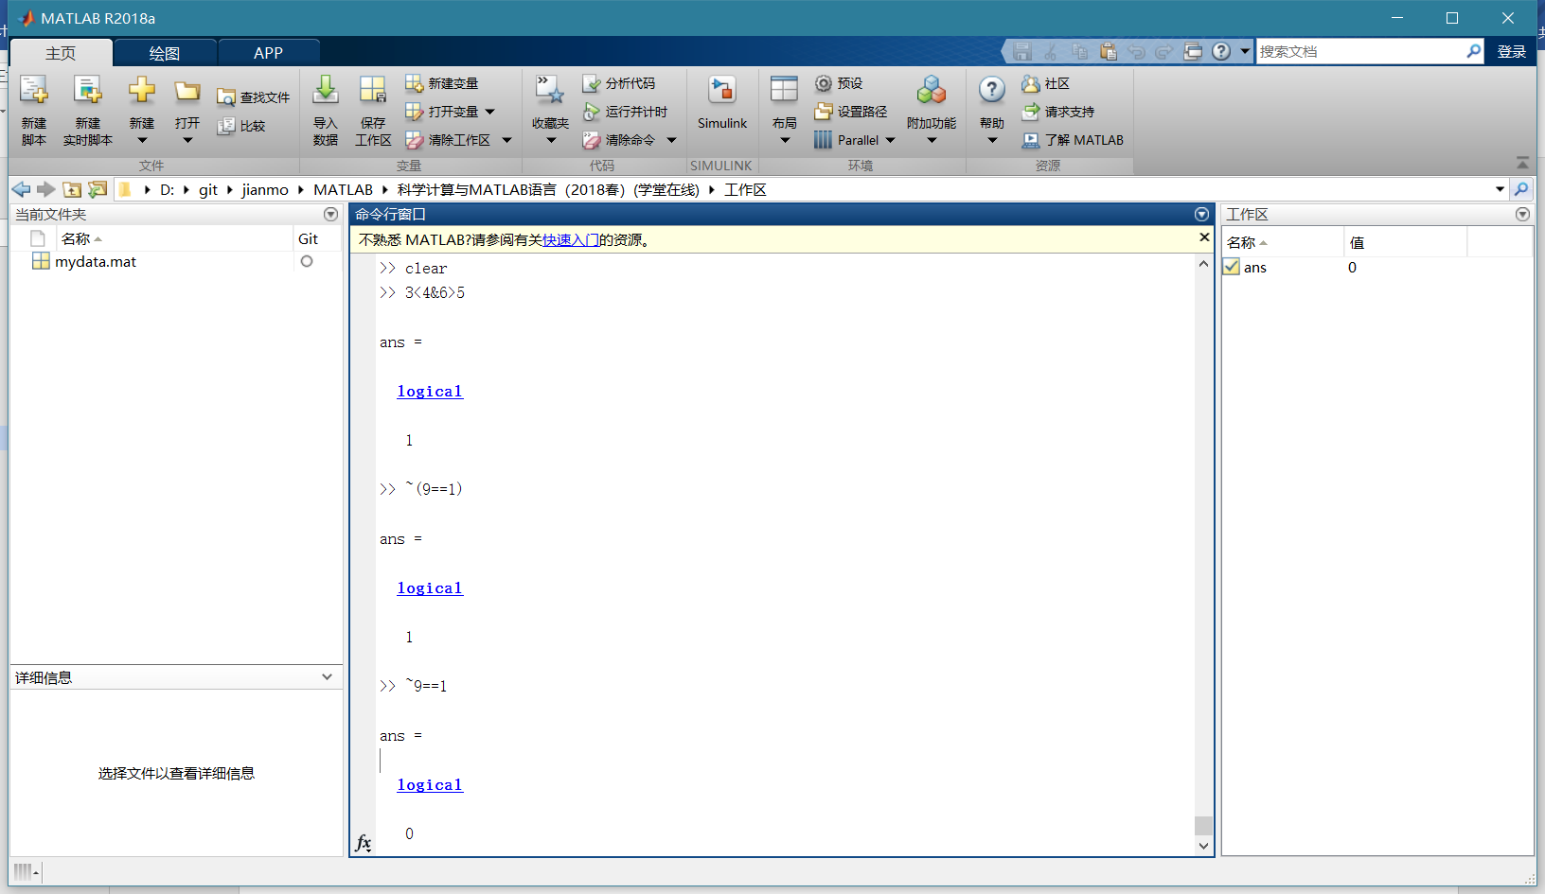

水仙花数

>> m=100:999;

>> m1=rem(m,10);

>> m2=rem(fix(m/10),10);

>> m3=fix(m/100);

>> k=find(m==m1.*m1.*m1+m2.*m2.*m2+m3.*m3.*m3)

k =

54 271 272 308

>> s=m(k)

s =

153 370 371 407

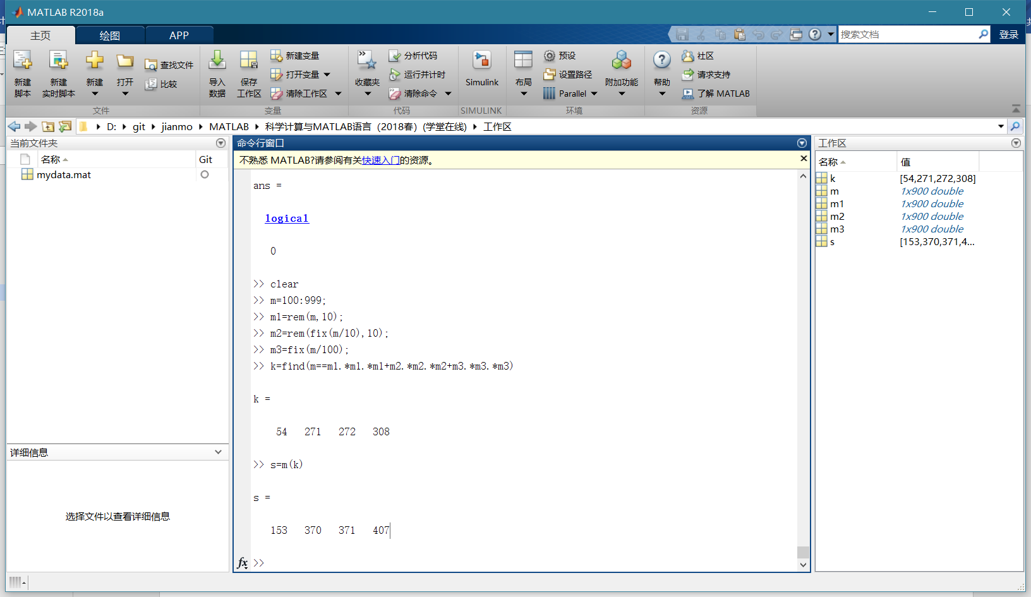

## 字符串处理

>> xm='Central South University'

xm =

'Central South University'

>> xm(1:3)

ans =

'Cen'

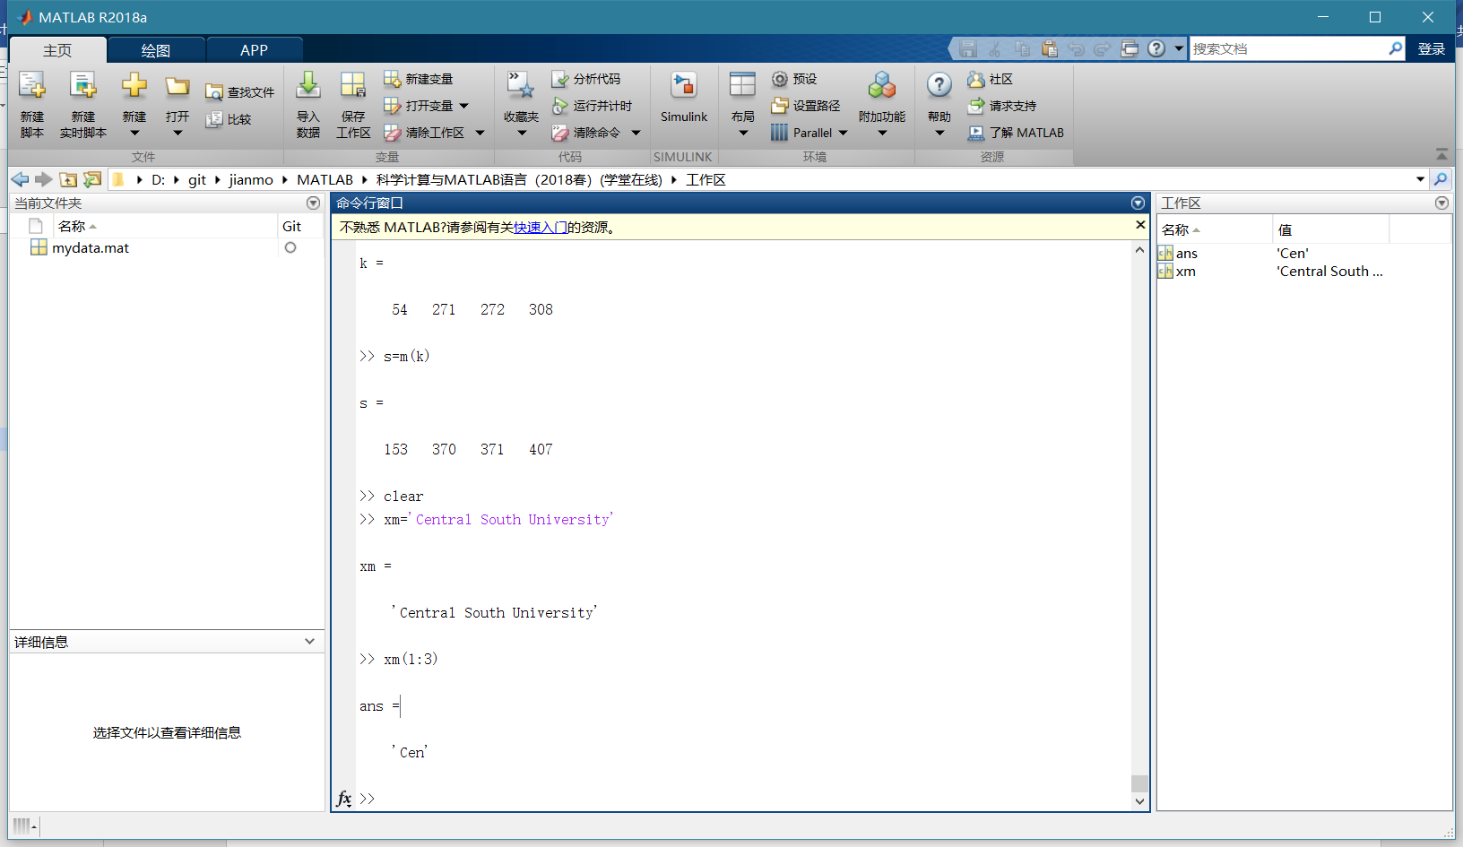

>> ch=['abcdef';'123456']

ch =

2×6 char 数组

'abcdef'

'123456'

>> ch(2,3)

ans =

'3'

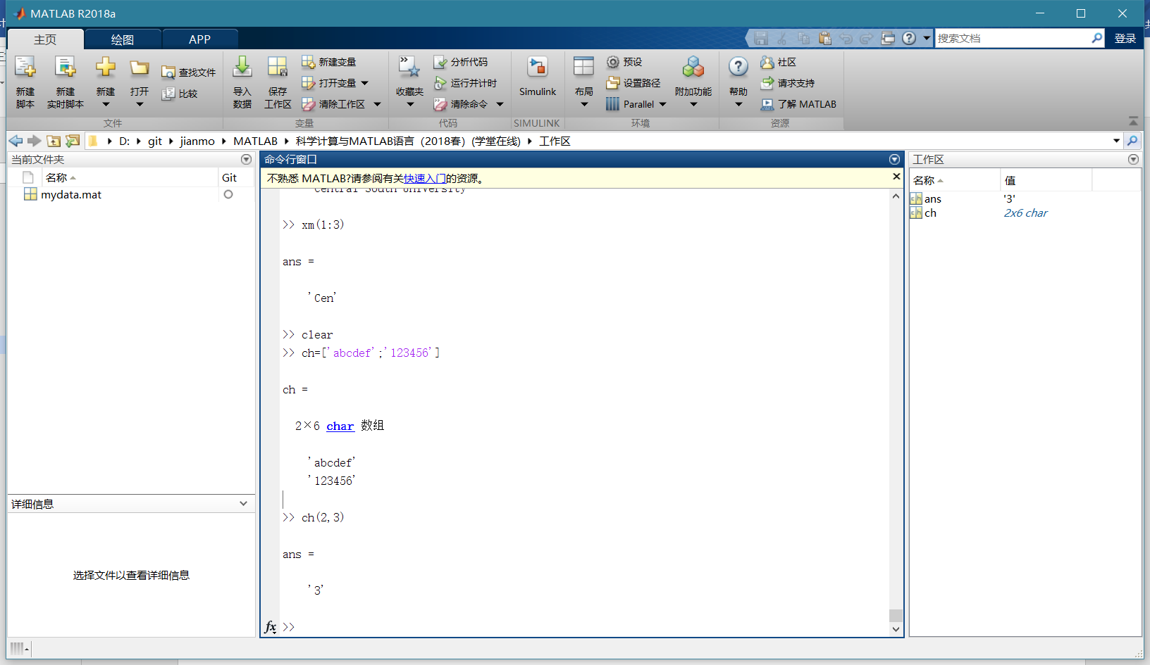

>> ch='ABc123d4e56Fg9'

ch =

'ABc123d4e56Fg9'

>> subch=ch(1:5)

subch =

'ABc12'

>> revch=ch(end:-1:1)

revch =

'9gF65e4d321cBA'

>> k=find(ch>='a'&ch<='z')

k =

3 7 9 13

>> ch(k)=ch(k)-('a'-'A')

ch =

'ABC123D4E56FG9'

>> length(k)

ans =

4

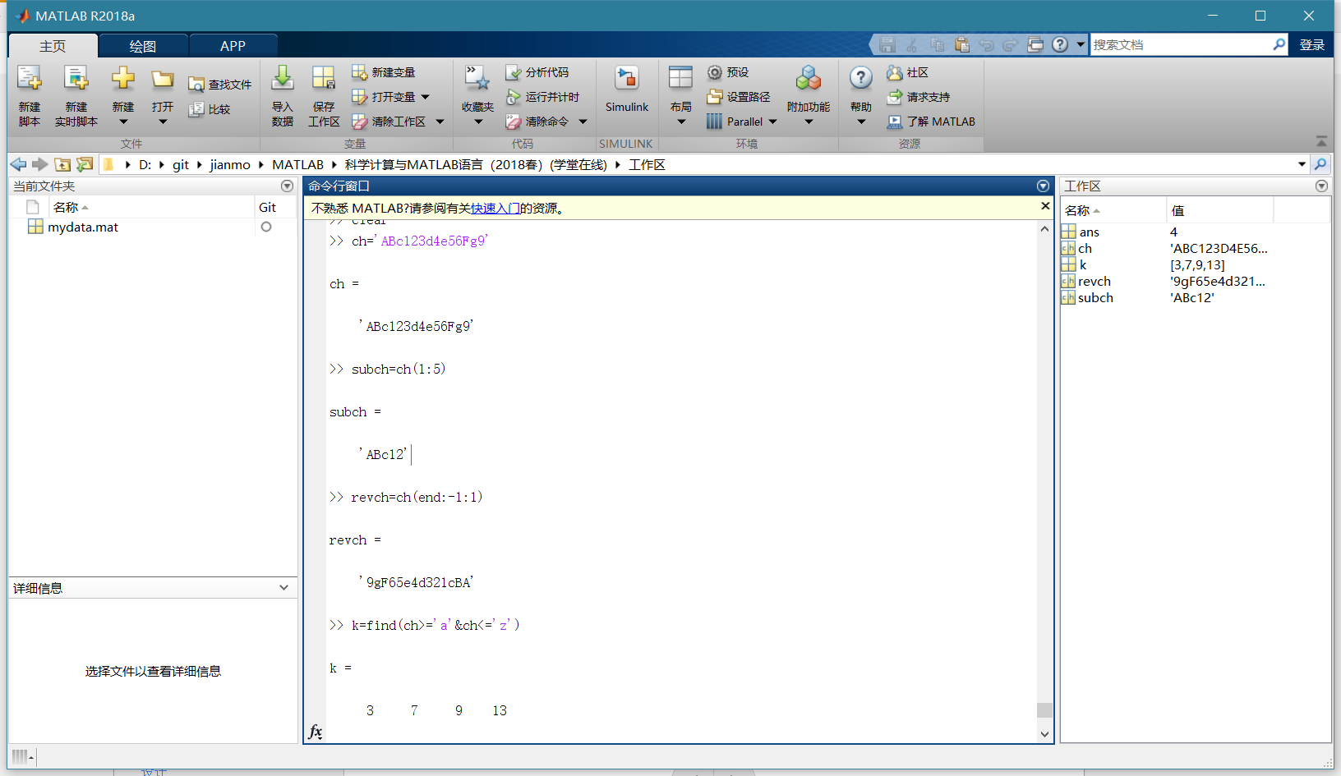

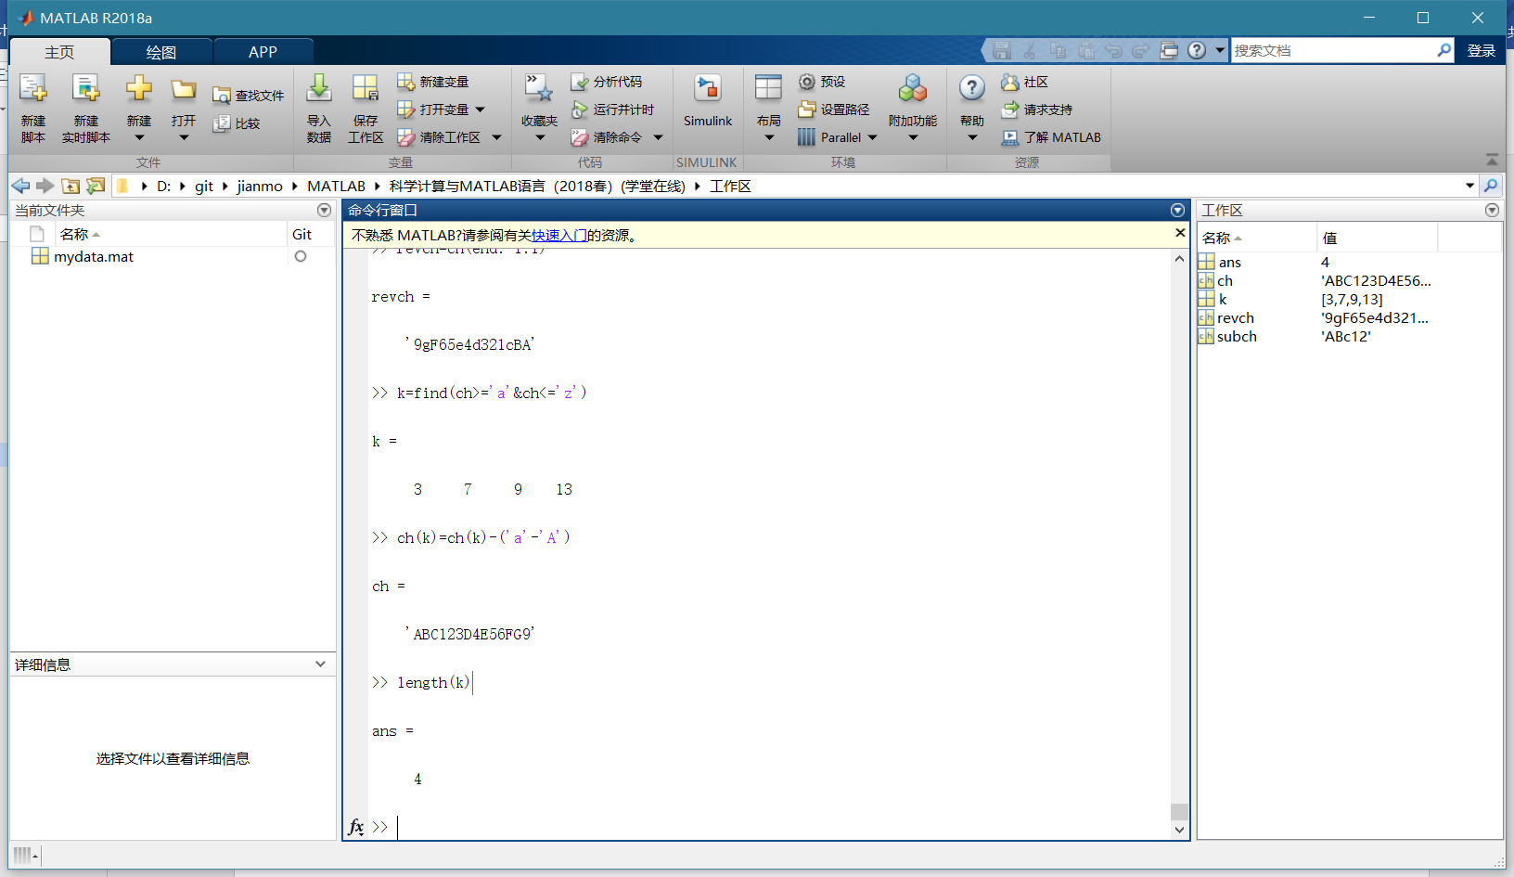

>> t=pi;

>> m='[t,sin(t),cos(t)]';

>> y=eval(m)

y =

3.1416 0.0000 -1.0000

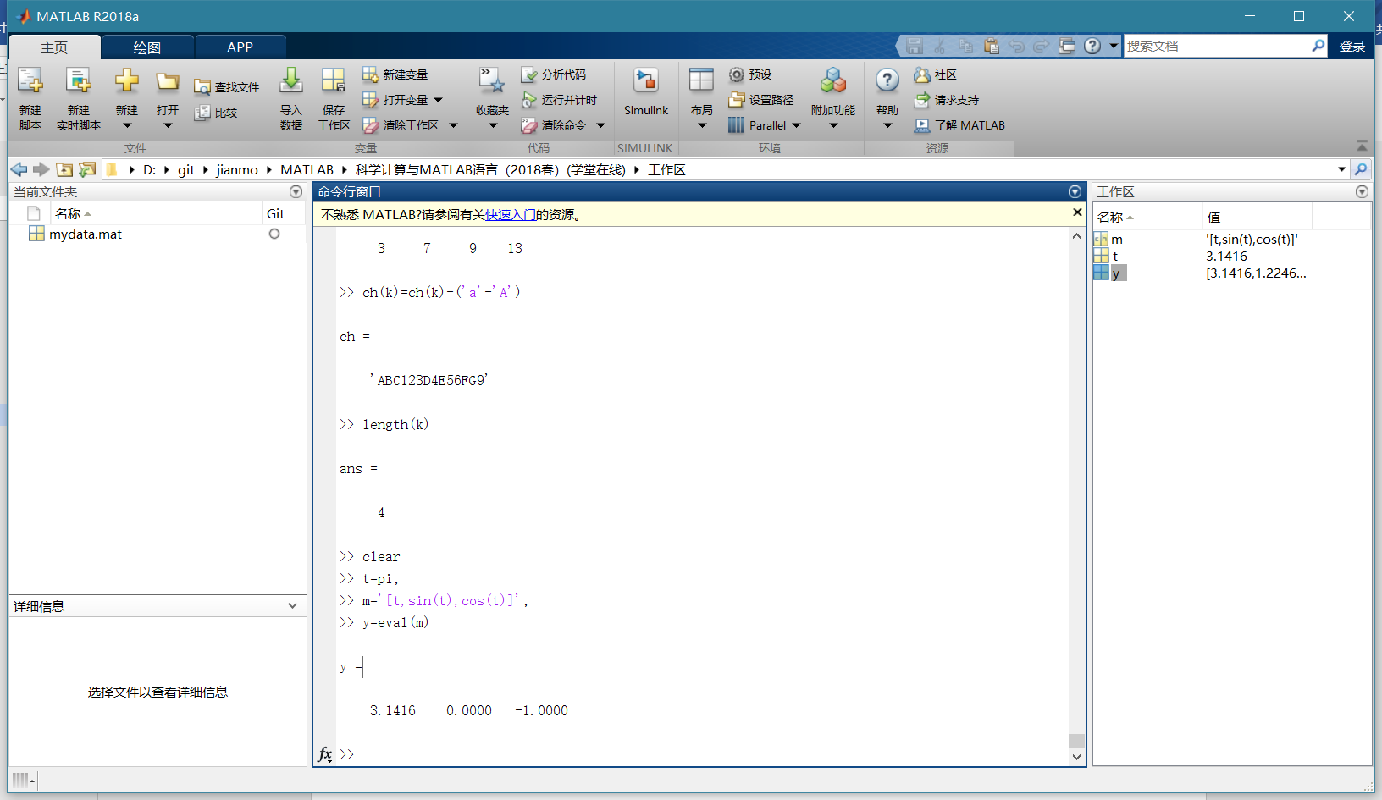

>> s1='MATLAB';

>> a=abs(s1)

a =

77 65 84 76 65 66

>> char(a+32)

ans =

'matlab'

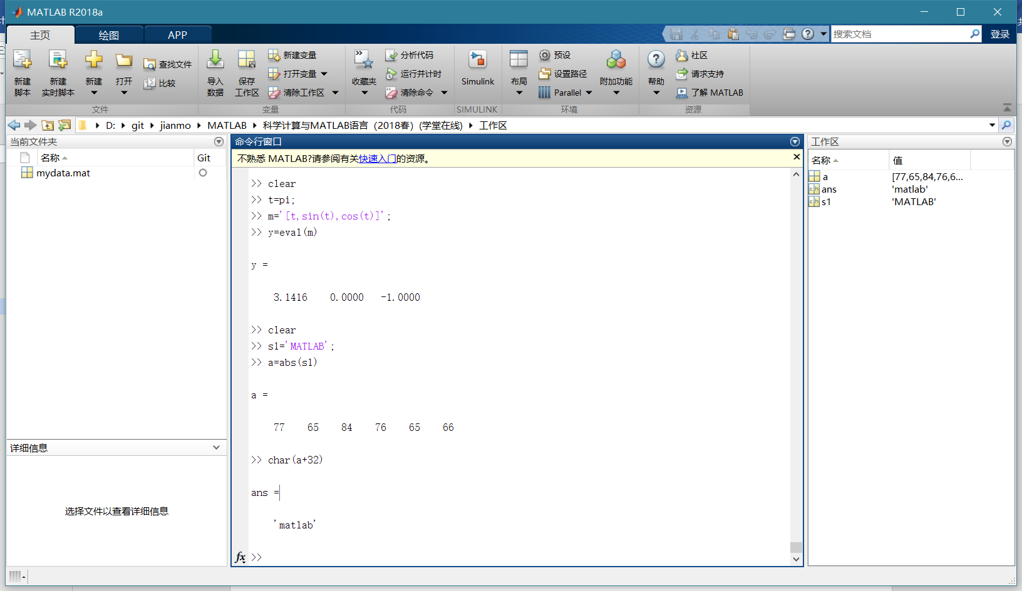

>> 'www0'>='W123'

ans =

1×4 logical 数组

1 1 1 0

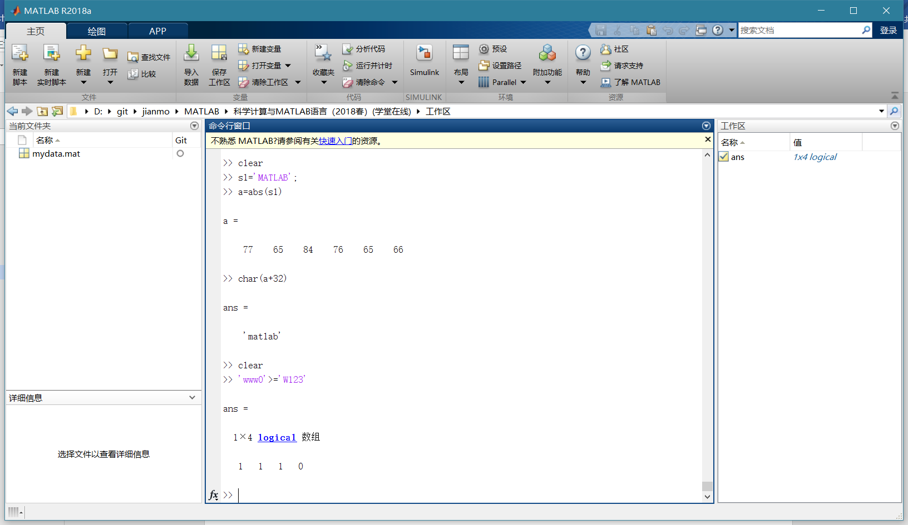

>> strcmp('www0','w123')

ans =

logical

0

>> strncmpi('Www0','w123',1)

ans =

logical

1

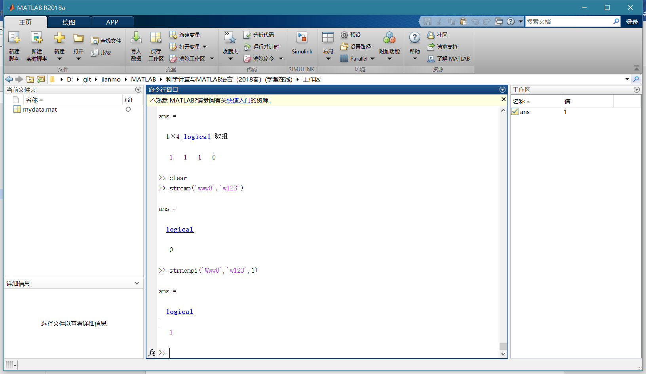

>> p=findstr('This is a test!','is')

p =

3 6

>> p=findstr('is','This is a test!')

p =

3 6

>> result=strrep('This is a test!','test','class')

result =

'This is a class!'

